
AIMS Animal Science, 1 (1): 181–195.
DOI: 10.3934/aas.2025009
Received: 17 September 2025
Revised: 19 November 2025
Accepted: 28 November 2025
Published: 25 December 2025
https://www.aimspress.com/journal/aas

Perspective
Amdoparvoviruses. Part 1. Phylogenetic analysis of complete VP2 protein sequences provided support for a global taxonomic analysis of the Aleutian mink disease virus
Irina Zyrianova*
Department of Biotechnology, FSBSI V.A. Afanasyev RI for Fur and Rabbit Farming, Moscow region, Ramenki district, Rodniki, 140143 Russian Federation
* Correspondence: Email: mirsimzyrianova@mail.ru.

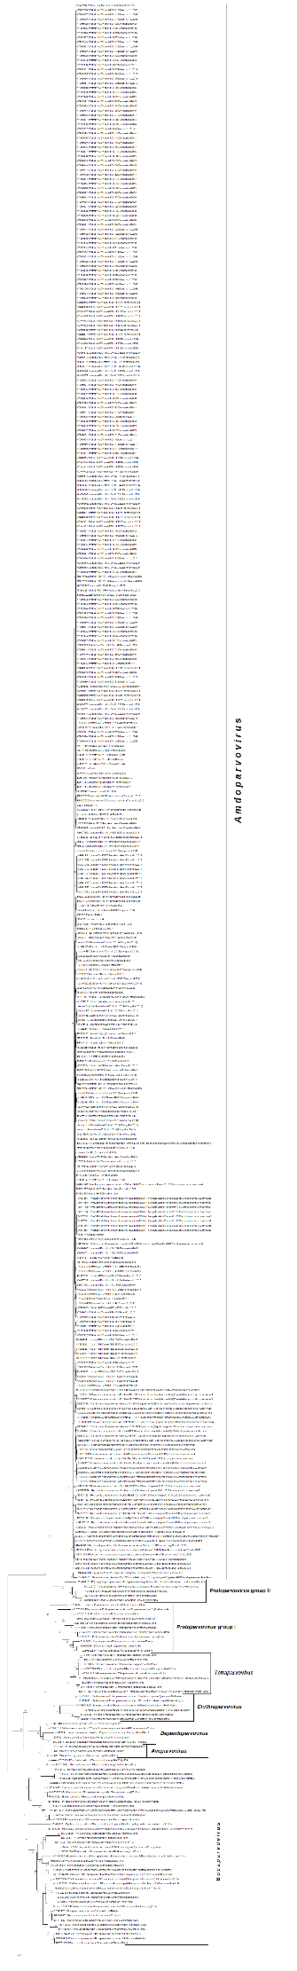
Supplementary Figure 1. The evolutionary tree of VP2 protein sequences of Parvovirinae representatives with the highest log likelihood (-67518.55). Numbers are the percentage of trees in which the associated taxa are clustered together, shown next to the branches. https://doi.org/10.6084/m9.figshare.30095770.v2

