
MBE, 21 (9): 7087–7101.
DOI: 10.3934/mbe.2024312
Received: 28 February 2024
Revised: 15 August 2024
Accepted: 26 August 2024
Published: 12 September 2024
http://www.aimspress.com/journal/MBE

Research article
Vaccine-induced reduction of COVID-19 clusters in school settings in Japan during the epidemic wave caused by B.1.1.529 (Omicron) BA.2, 2022
Yuta Okada and Hiroshi Nishiura*
Kyoto University School of Public Health, Yoshida-Konoe, Sakyo-ku, Kyoto 606-8601, Japan
* Correspondence: Email: nishiura.hiroshi.5r@kyoto-u.ac.jp; Tel: +81-75-753-4456; Fax: +81-75- 753-4458.

Supplementary Methods
- Modeling of $J_{a, t}$ using the renewal equation.
The number of infected individuals in age group $a$ contributing to infection in week $t$, $J_{a, t}$, is described as follows:
$$J_{a, t}=\sum_{l=0}^{6}{\sum_{τ=1}^{∞}{I_{a, t-l-τ}g\left(τ\right)}},$$
where $I_{a, t}$ ($a:$0–19, 20–59, or 60+ years) is the back-calculated infection count by date of infection in age group $a$ at week $t$, and $g$ is the probability mass function of the generation time.
- Modeling of the variation of scaling factor over time.
We assumed that the scaling factor $κ_{t}$ varied over time, which is described as follows:
$$\log\left(κ_{t}\right)\sim Normal\left(\log\left(κ_{t-1}\right), σ_{κ}\right),$$
where $σ_{κ}$ is standard deviation of the normal distribution that manifests the temporal random walk of $κ_{t}$.
- Probability distribution of the time delay from illness onset to reporting, as estimated from COVID-19 data in Tokyo from January–September 2022.
Weibull shape parameter=2.168 (95%CI: 2.165–2.171)
Weibull scale parameter=4.998 (95%CI: 4.994–5.001)
The 95% confidence interval was obtained by the parametric bootstrap technique using the Hessian matrix derived from the negative log-likelihood. We used the median estimates of resampled distributions for the main analysis.

- Prior distributions used for the estimation.
$\log\left(κ_{t}\right) \sim Normal\left(\log\left(\frac{∑clusters}{∑cases}\right), 0.1\right)$ ,
$\log\left(β_{a}\right) \sim Normal\left(0, 1\right)$,
$\log\left(σ_{κ}\right) \sim Half CauchyN\left(0, 1\right)$,
where $∑clusters$ and $∑cases$ are the total numbers of school clusters and cases within the study period, respectively.

- Estimation result of standard deviation $σ_{κ}$ that controls the time-varying factor $κ_{t}$
$σ_{κ}$: 0.269 (95% CrI: 0.195-0.394)

Supplementary Figure
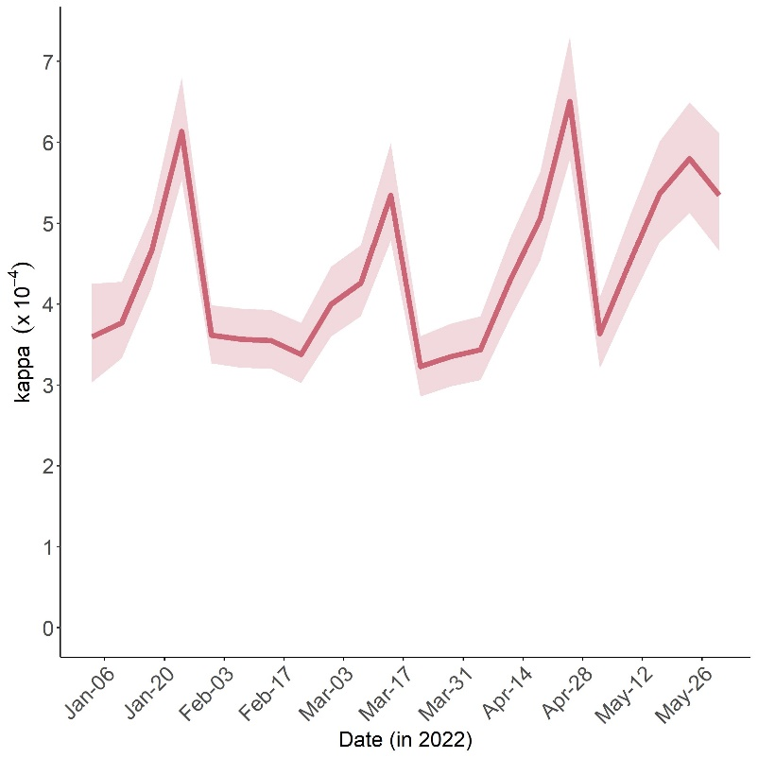
Supplementary Figure 1. Estimated expected values of the scaling factor $κ_{t}$ of our statistical model throughout the study period, 2022. In each time step, the solid red line represents the median and the shaded area corresponds to the 95% credible interval.

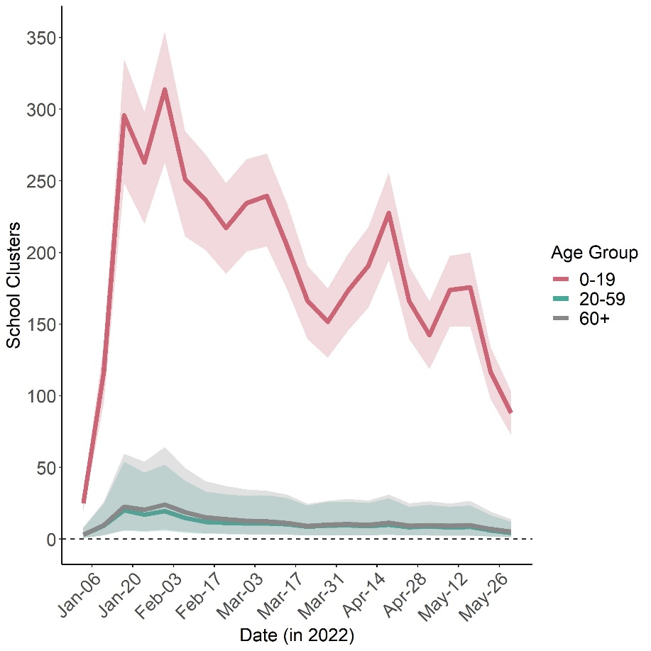
Supplementary Figure 2. Estimated contribution to school cluster occurrence by age groups 0-19, 20-59, and 60+. Red, green, and grey line with shades represent contribution of infectors in 0-19, 20-59, and 60+, respectively. In each time step, the solid line represents the median and the shaded area corresponds to the 95% credible interval.

Supplementary Table
- Changes in the cumulative number of school clusters by counterfactual scenario with accelerated roll-out and/or elevated vaccination coverage compared with the actual vaccination campaign.
The “5–11 yo 2nd”, “12–17 yo 2nd ”, and “12–17 yo 3rd” columns show constant multiples that reflect the extent of elevation in the vaccination coverage in the counterfactual scenarios in each row, whereas the “Weeks advanced” column describes the number of weeks accelerated (shortened) for 2nd dose for those aged 5–11 years or 3rd dose for those aged 12–17 years. The coverage rates of 2nd and 3rd doses as of May 30, 2022 for the entire population aged 0–19 years are shown in the “2nd vaccine coverage” and “3rd vaccine coverage” columns, respectively. The last row is for scenario 5 as described in the maintext, where it was assumed that the entire population received the third vaccine on Dec 18, 2021.

5-11 yo  2nd | 12-17 yo  2nd | 2nd vaccine coverage | 12-17 yo  3rd | 3rd vaccine coverage | Weeks  advanced | $∆λ\left(S, A\right)$ (95% CrI)
*1 | *1 | 33.9 % | *1 | 9.3 % | 0 | ref
*4 | *1 | 45.4 % | *1 | 9.3 % | 0 | -30.4 (-31.8, -28.3)
*8 | *1 | 60.1 % | *1 | 9.3 % | 0 | -70.1 (-74.3, -66.0)
*1 | *1.5 | 44.3 % | *1 | 9.3 % | 0 | -69.1 (-71.1, -67.2)
*1 | *1.5 | 44.3 % | *4 | 26.9 % | 0 | -76.0 (-78.2, -73.9)
*4 | *1.5 | 55.8 % | *4 | 26.9 % | 0 | -106.0 (-109.4, -102.8)
*8 | *1.5 | 71.2 % | *4 | 26.9 % | 0 | -146.1 (-151.6, 140.8)
*4 | *1 | 48.7 % | *1 | 9.3 % | 4 | -90.7 (-94.6, -86.8)
*8 | *1 | 67.3 % | *1 | 9.3 % | 4 | -191.4 (-199.7, -183.0)
*1 | *1.5 | 44.3 % | *4 | 33.1 % | 4 | -193.4 (-200.9, -186.3)
*4 | *1.5 | 59.1 % | *4 | 33.1 % | 4 | -284.1 (-295.0, -273.4)
*8 | *1.5 | 77.7 % | *4 | 33.1 % | 4 | -384.9 (-400.0, -369.9)
*4 | *1 | 50.0 % | *1 | 9.3 % | 8 | -150.3 (-155.9, -145.0)
*8 | *1 | 70.1 % | *1 | 9.3 % | 8 | -310.6 (-322.1, -299.7)
*1 | *1.5 | 44.3 % | *4 | 37.3% | 8 | -335.8 (-348.2, -324.1)
*4 | *1.5 | 60.4 % | *4 | 37.3% | 8 | -486.1 (-503.9, -469.4)
*8 | *1.5 | 80.5 % | *4 | 37.3% | 8 | -646.5 (-670.1, -624.3)
- | - | 100% | - | 100% | (On Dec 18, 2021) | -2101 (-2161, -2044)

