MBE, 20(10): 18318–18344.
DOI: 10.3934/mbe.2023814
Received: 03 July 2023
Revised: 12 August 2023
Accepted: 23 August 2023
Published: 22 September 2023
http://www.aimspress.com/journal/MBE

Research article
Multi-omics analysis and validation of the tumor microenvironment of hepatocellular carcinoma under RNA modification patterns
Yuanqian Yao¹, Jianlin Lv², Guangyao Wang² and Xiaohua Hong^{1,}*
¹ Guangxi University of Chinese medicine, NanNing 530000, China
² The First Affiliated Hospital of Guangxi University of Chinese Medicine, Nanning 530000, China
* Correspondence: Email: hongxiaohua613@163.com; Tel: +86-17877007330.
Supplementary Figures
Figure S1. The mutation profile of RNA modification-regulating genes in the LIHC cohort.
Figure S2. RNA modification-regulating genes with significant prognostic value in HCC.
Figure S3. Validation of RNAM-S in overall cohort. (A) PCA analysis in overall cohort. (B) KM analysis of the OS between the two HCC groups. (C) ROC curves to predict the sensitivity and specificity of 1-, 3-, and 5-year survival according to the RNAM-S. (D,E) The scatter plot presenting the HCC patients’ survival status.
Figure S4. Validation of RNAM-S in test cohort. (A) PCA analysis in test cohort. (B) KM analysis of the OS between the two HCC groups. (C) ROC curves to predict the sensitivity and specificity of 1-, 3-, and 5-year survival according to the RNAM-S. (D,E) The scatter plot presenting the HCC patients’ survival status.
Figure S5. Independence of the RNAM-S in stratified analysis. KM survival curves in high- and low-risk patients stratified by age (A,D), gender (B,E) and Stage (C,F).
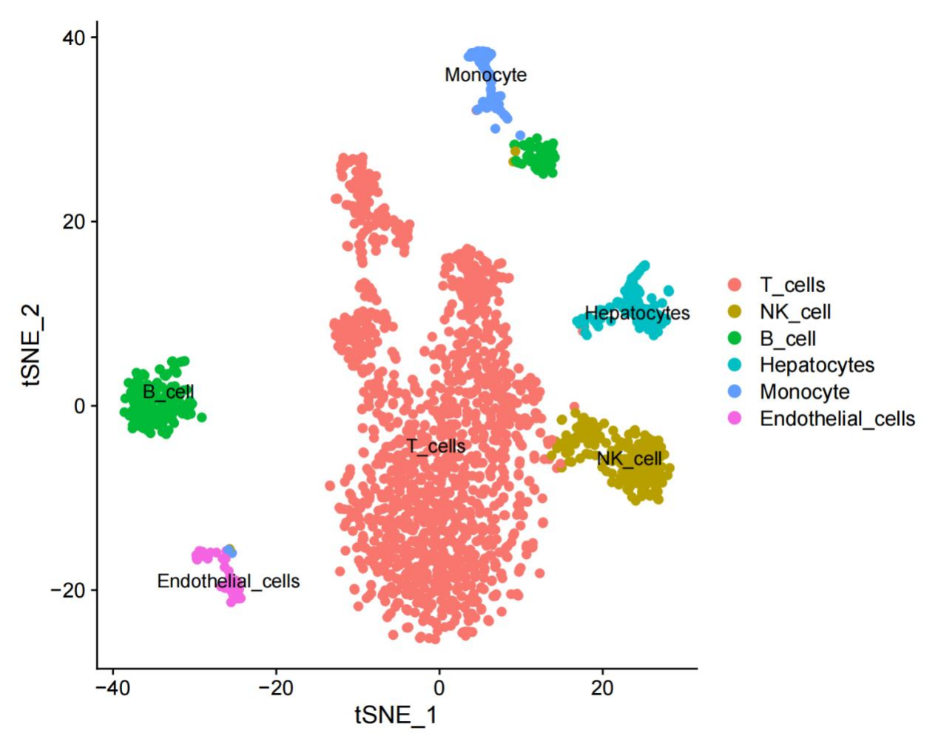
Figure S6. Identify various types of cell populations in the TME of HCC. The TME of HCC was found to contain six types of cell populations: T cells, NK cells, B cells, hepatocytes, monocytes and endothelial cells.
Figure S7. Expression of the four prognostic genes in pan-cancer and their relationship with prognosis. (A–D): Expression of the four prognostic genes in pan-cancer. (E–H): Relationship between the expression of the four prognostic genes and OS in pan-cancer.
Figure S8. Immune analysis of the four prognostic genes in pan-cancer. (A–D) Correlation between the four genes and 150 immune modulators. (E–H) Relationship between the four genes and two major immune checkpoints.
Figure S9. Immune analysis of the four prognostic genes in pan-cancer. (A–D) Relationship between the four genes and immune infiltration (XCELL database).
©2023 the Author(s), licensee AIMS Press. This is an open access article distributed under the terms of the Creative Commons Attribution License (http://creativecommons.org/licenses/by/4.0)

