MBE, 20 (9): 16824–16845.
DOI: 10.3934/mbe.2023750
Received: 30 June 2023
Revised: 29 July 2023
Accepted: 13 August 2023
Published: 23 August 2023
http://www.aimspress.com/journal/MBE

Research article
Spatiotemporal retrieval and feature analysis of air pollution episodes
Peng-Yeng Yin*
Information Technology and Management Program, Ming Chuan University, 5 De-Ming Road, Gui-Shan District, Taoyuan City, 333321, Taiwan
* Correspondence: Email: pyyin@mail.mcu.edu.tw; Tel: +886-3-350-7001.

Supplement
- Sobel and Roberts edge detectors
As a supplement to the main text, we introduce the Sobel and Roberts edge operators as follows. The Sobel operator uses four 3×3 filters as shown in Figure 1 to detect vertical, horizontal and oblique edges in an image. The edges produced by the Sobel operator are significant for high variations in the image due to the higher weight emphasized in the filters.
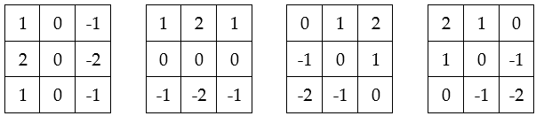
Figure 1. Sobel edge filters for detecting vertical, horizontal and two oblique edges.
The Roberts operator, on the other hand, uses only two 2×2 filters as shown in Figure 2 to detect edges in an image. As the Roberts filters are smaller than the Sobel filters, the Roberts detector is computationally fast, but it is sensitive to background noises.
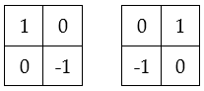
Figure 2. Roberts edge filters for detecting vertical, horizontal and two oblique edges.
- Retrieved episodes by QBS
As a supplement to the main text, we present the results of the QBS query described in Figure 3 (corresponding to Figure 11 in the main text). The retrieved pollution episodes are shown in Figure 4 and are displayed in the order of decreasing similarity score to the QBS query. As can be seen in the figure, the first seven episodes have the highest similarity score of 0.756756, followed by the next seven episodes, which have a similarity score of 0.729729. The last two episodes in the second row and the first episode in the third row have a different alert level for the outer object in the QBS query, and they rank with the third similarity score of 0.716216. For the next five episodes in the same row, they rank as fourth with a similarity score of 0.702702 because they have a larger inner object. The remaining episodes except the last one are in the fifth-rank group because they have a smaller inner object and a different alert level for the outer object. The last retrieved episode ranks as the sixth with a similarity score of 0.675675. This is mainly because the episode has one more object than the QBS query.
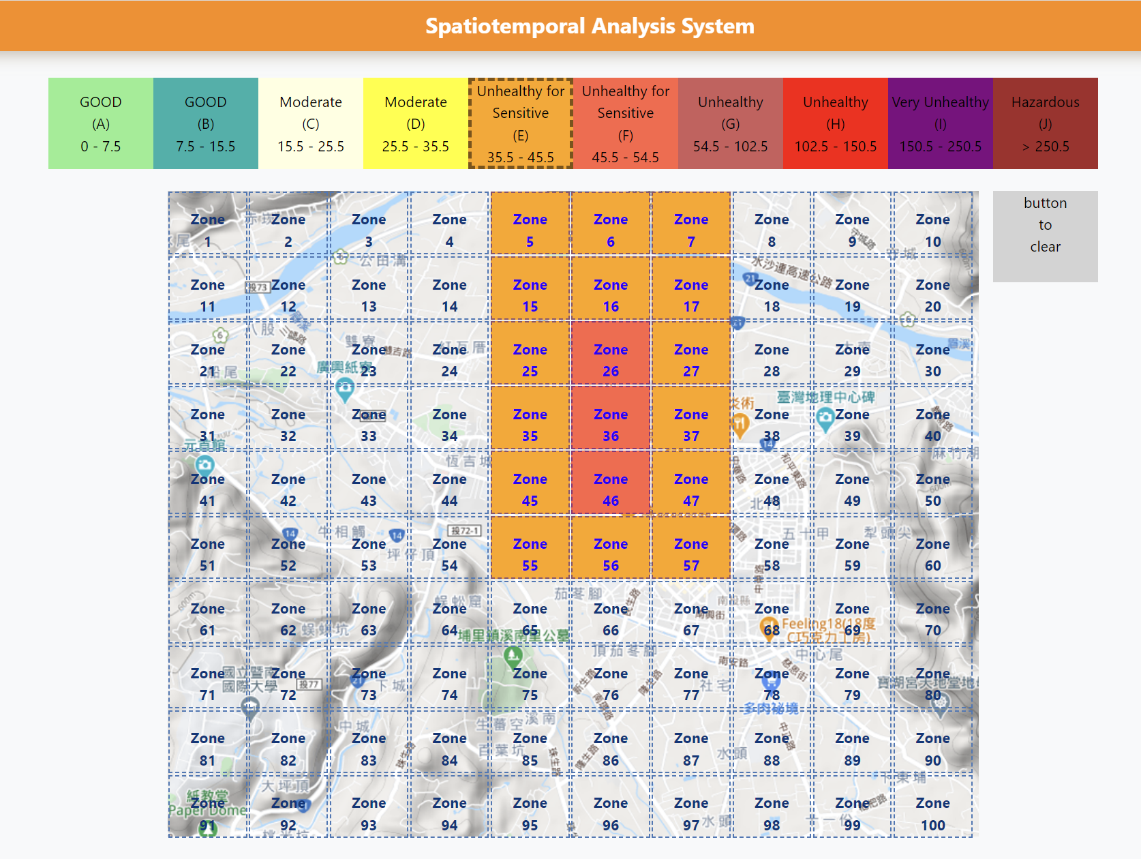
Figure 3. A QBS example where the user sketches an iconic query.

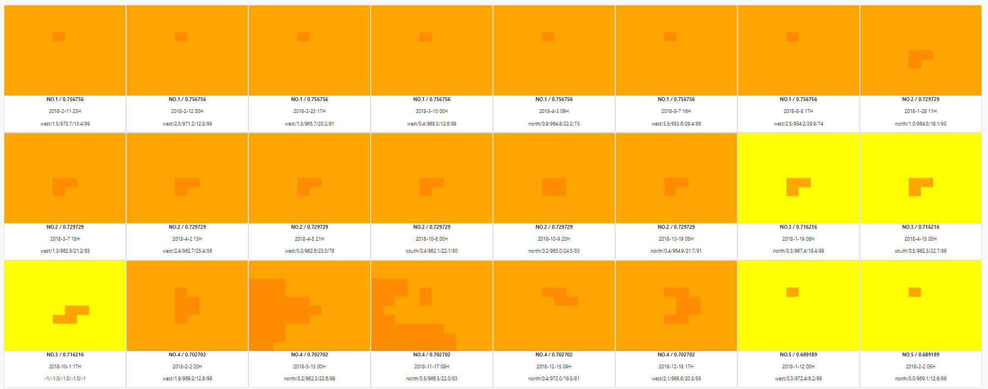
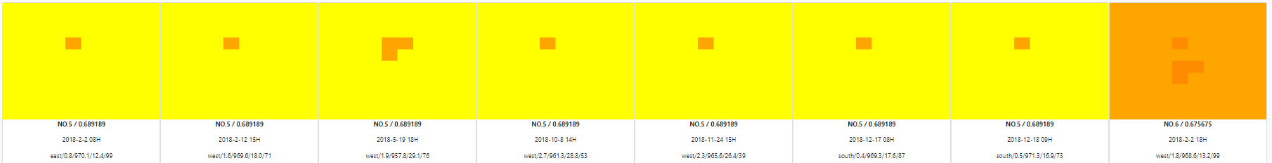
Figure 4. The retrieved episodes for the QBS query submitted in Figure 3.

