MBE, 20(6): 10339–10357.
DOI: 10.3934/mbe.2023xxx
Received: 09 December 2022
Revised: 16 February 2023
Accepted: 28 February 2023
Published: 31 March 2023
http://www.aimspress.com/journal/MBE

Research article
Development and validation of two redox-related genes associated with prognosis and immune microenvironment in endometrial carcinoma
Yan He^{1,2,}†, Nannan Cao^{2,}†, Yanan Tian^{1,2}, Xuelin Wang², Qiaohong Xiao², Xiaojuan Tang³, Jiaolong Huang², Tingting Zhu², Chunhui Hu⁴, Ying Zhang⁵, Jie Deng², Han Yu^{2,6,}* and Peng Duan^{2,}*
- Postgraduate Union Training Base of Jinzhou Medical University, Xiangyang No.1 People’s Hospital, Hubei University of Medicine, Xiangyang 441000, China
- Affiliation Key Laboratory of Zebrafish Modeling and Drug Screening for Human Diseases of Xiangyang City, Department of Obstetrics and Gynaecology, Xiangyang No. 1 People’s Hospital, Hubei University of Medicine, Xiangyang 441000, China
- Department of Radiography center, Renmin Hospital, Hubei University of Medicine, Shiyan 442000, China
- Department of Clinical Laboratory, Xiangyang No.1 People’s Hospital, Hubei University of Medicine, Xiangyang 441000, China
- Laboratory of Medical Genetics, Harbin Medical University, Harbin 150000, China
- Department of Pathology, Xiangyang No.1 People’s Hospital, Hubei University of Medicine, Xiangyang 441000, China
* Correspondence: Email: yuhanqh@163.com, meduanpeng@163.com.
† These two authors contributed equally.

Supplementary
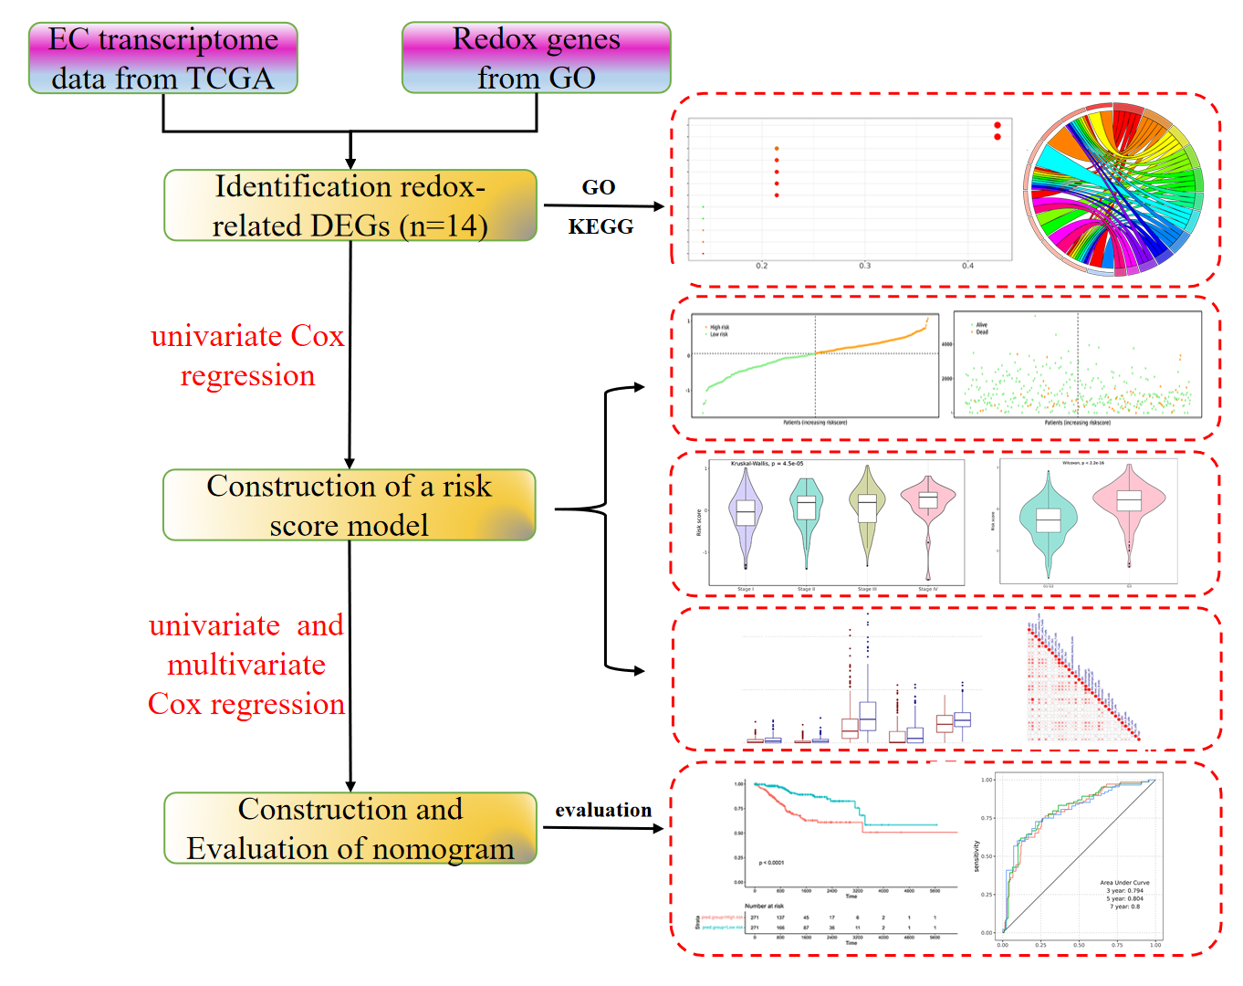
Figure S1. The flowchart of this study.
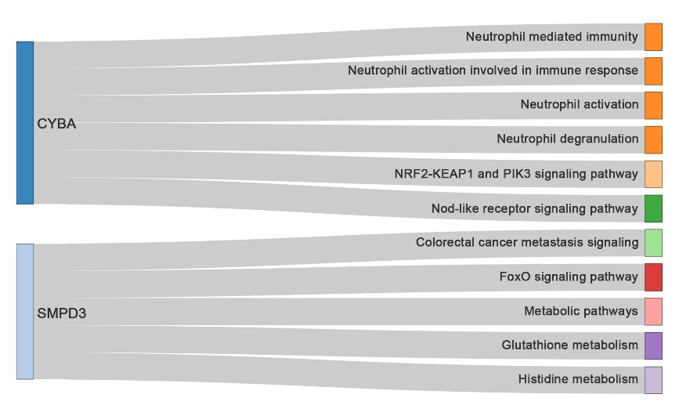
Figure S2. Signal pathways and GO terms involved in two key genes in certain tumors.
Figure S3. Difference of the risk scores in EC patients with different clinical characteristics. (a) The relationship between the risk scores and clinical stage in TCGA-UCEC datasets. (b) The relationship between the risk scores and tumor grade in TCGA-UCEC datasets.
Figure S4. GSVA analysis of low- and high-risk groups. (a) KEGG analysis of low- and high-risk groups. (b–d) BP, CC and MF of low- and high-risk groups. Red dots indicate high risk group samples, blue dots indicate low risk group samples. P value < 0.05.
Figure S5. The immune cell infiltration in the TCGA-UCEC cohort. (a) Heatmap of immune cells infiltration in low- and high-risk groups. (b) The correlation analysis between immune cells.
Figure S6. The gene mutation profile in low-risk and high-risk groups. (a, b) the top 20 mutated genes in low-risk and high-risk groups. (c) The mutation profile among low-risk and high-risk groups. (d) Word cloud of mutated genes.
Figure S7. Analysis of gene variant classifications and types in the TCGA-UCEC cohort.
Figure S8. The mutation profile and co-occurence of CYBA and SMPD3. (a) The mutation frequency of CYBA and SMPD3 in the TCGA-UCEC cohort. (b) Co-occurence among somatic mutation genes.
©2023 the Author(s), licensee AIMS Press. This is an open access article distributed under the terms of the Creative Commons Attribution License (http://creativecommons.org/licenses/by/4.0)

