MBE, 20 (12): 21499–21513.
DOI: 10.3934/mbe.2023951
Received: 30 August 2023
Revised: 09 November 2023
Accepted: 15 November 2023
Published: 05 December 2023
http://www.aimspress.com/journal/MBE

Research article
Epidemiological impact of travel enhancement on the inter-prefectural importation dynamics of COVID-19 in Japan, 2020
Asami Anzai¹, Syudo Yamasaki², Amanda Bleichrodt³, Gerardo Chowell³, Atsushi Nishida^{2,4} and Hiroshi Nishiura^{1,}*
¹ Graduate School of Medicine, Kyoto University, Yoshidakonoecho, Sakyo-ku, Kyoto 606-8501, Japan
² Research Center for Social Science & Medicine, Tokyo Metropolitan Institute of Medical Science, Setagaya-ku, Tokyo, Japan
³ School of Public Health, Georgia State University, 140 Decatur St., Atlanta, GA 30303, USA
⁴ Tokyo Center for Infectious Disease Control and Prevention, Shinjuku-ku, Tokyo, Japan
* Correspondence: Email: nishiura.hiroshi.5r@kyoto-u.ac.jp; Tel: +81-75-753-4456; Fax: +81-75-753-4458.

Supplementary material

A. Estimation of the growth rate of cases
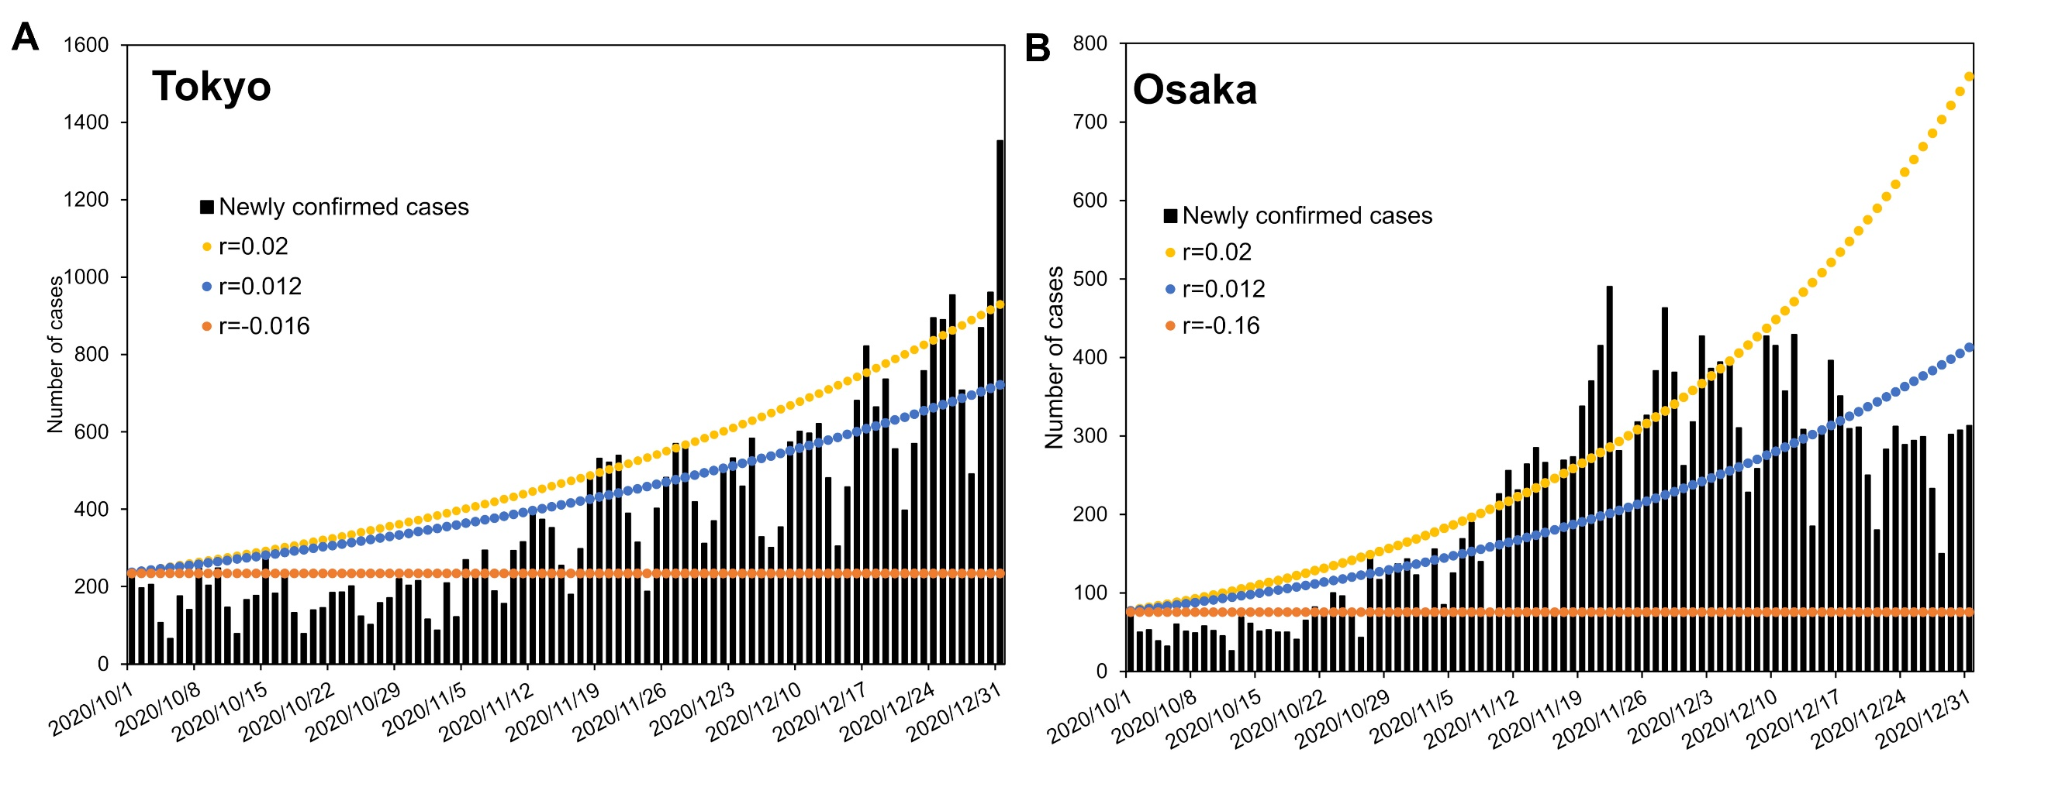
Supplementary Figure S1. Estimation of growth rate in Tokyo and Osaka. Newly confirmed COVID-19 cases (black bar) and three different epidemic curves with different growth rates from May 1 to October 31, 2020 are shown. Given those statistical estimates, we chose for the simulation in the main text the daily growth rate of −0.016 (yellow), 0.012 (green), and 0.020 (orange) per day. The rate −0.016 was the empirical estimate in November only in Tokyo, and 0.012 per day was the estimate from fitting the exponential growth to data from October to December in Tokyo. The largest value 0.020 per day was obtained as the upper bound of the estimate in Osaka by fitting the model to data from October to December, 2020.

B. Estimated number of imported cases by prefecture
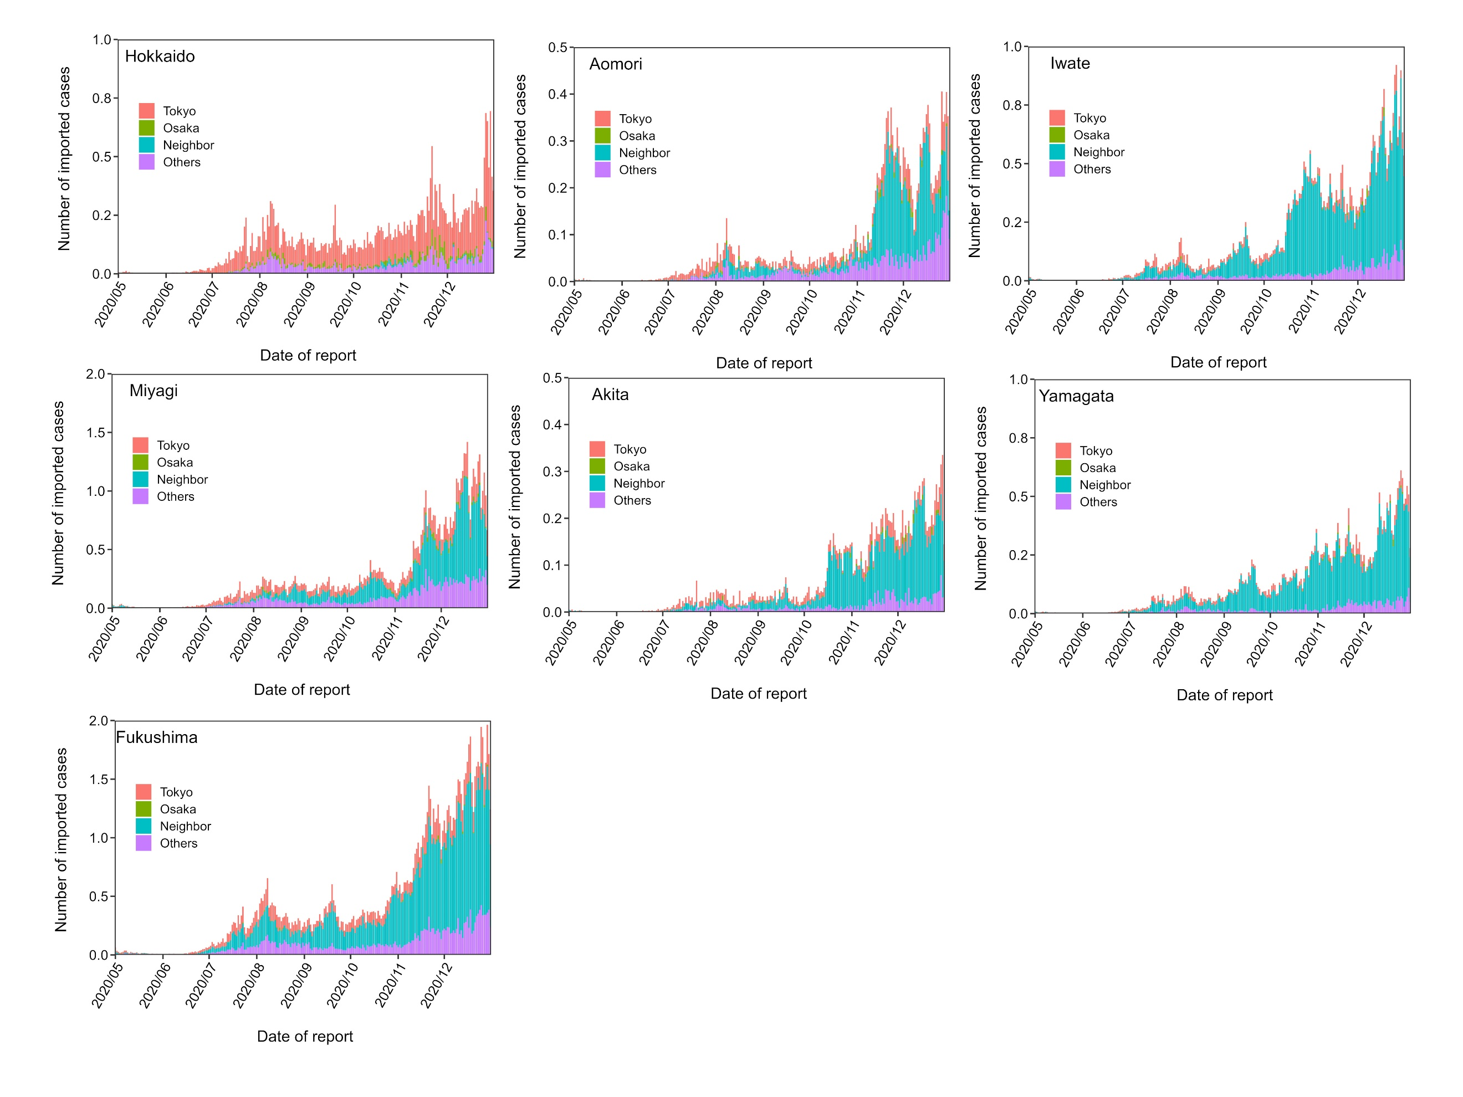
Supplementary Figure S2. Estimated number of imported cases in the Hokkaido and Tohoku regions. Estimates of the number of imported cases each day from May 1 to October 31, 2020 are shown. The daily estimates are divided into four groups according to characteristics of the originating prefecture: Tokyo (red), Osaka (green), neighboring prefectures (blue), and others (purple). The Hokkaido and Tohoku regions include Hokkaido, Aomori, Iwate, Miyagi, Akita, Yamagata, and Fukushima.

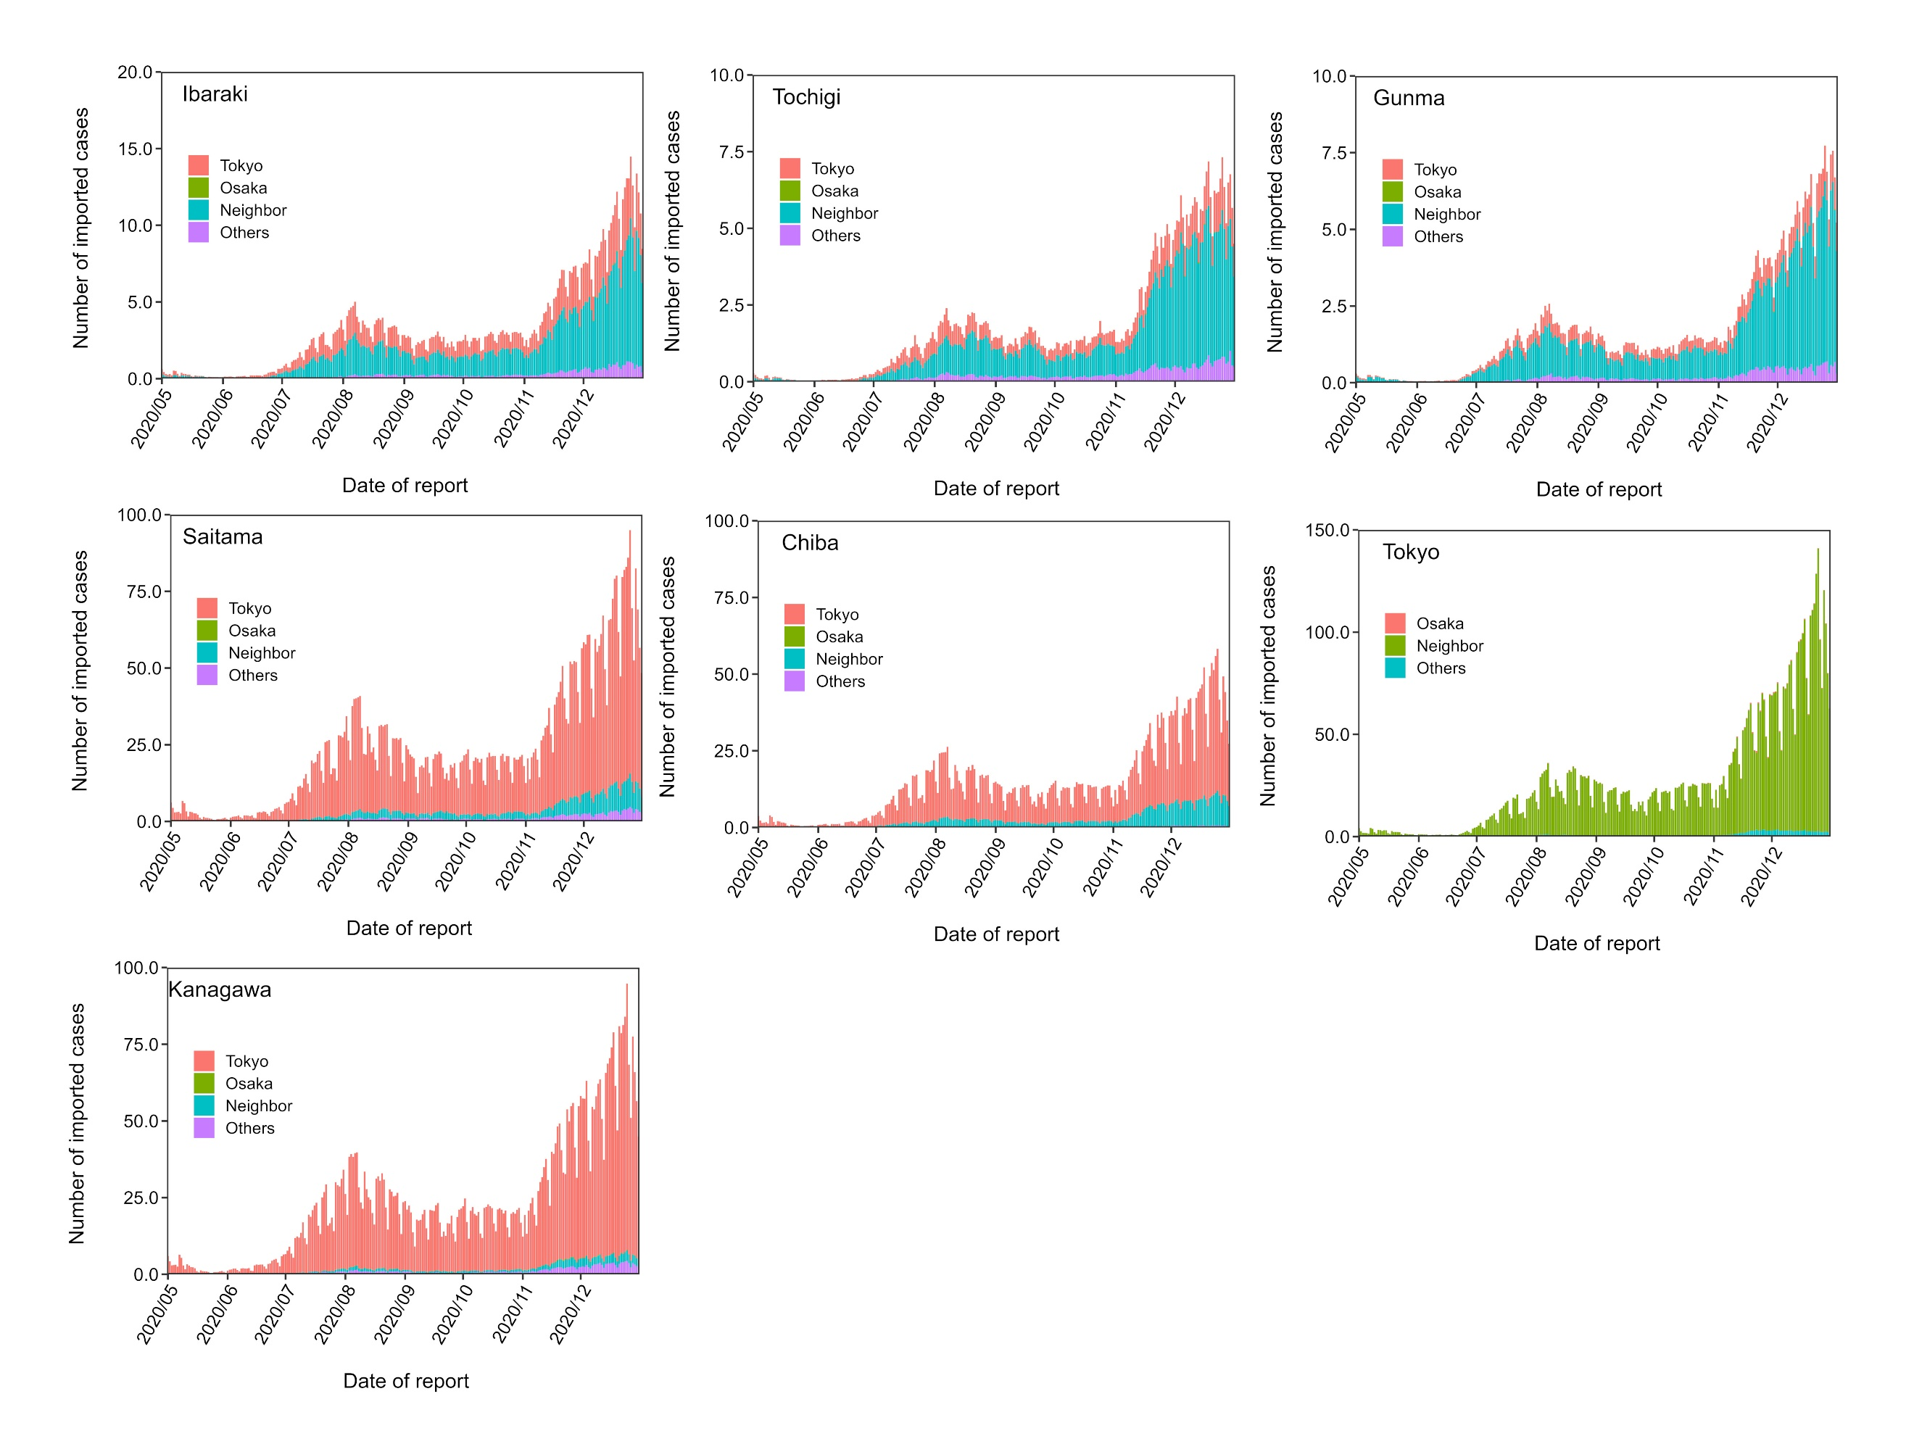
Supplementary Figure S3. Estimated number of imported cases in the Kanto region. Estimates of the number of imported cases each day from May 1 to October 31, 2020 are shown. The daily estimates are divided into four groups according to characteristics of the originating prefecture: Tokyo (red), Osaka (green), neighboring prefectures (blue), and others (purple). The Kanto region includes Ibaraki, Tochigi, Gunma, Saitama, Chiba, Tokyo and Kanagawa.

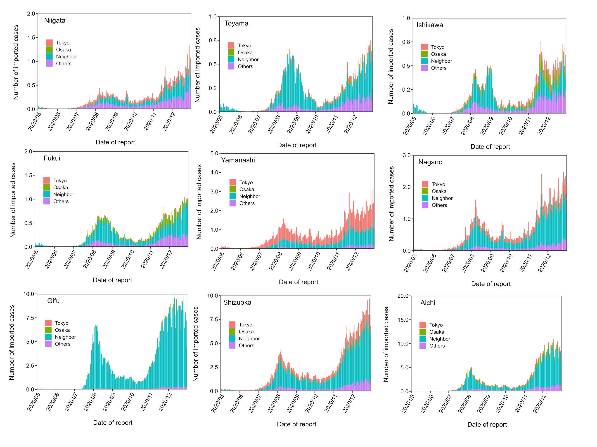
Supplementary Figure S4. Estimated number of imported cases in the Chubu region. Estimates of the number of imported cases each day from May 1 to October 31, 2020 are shown. The daily estimates are divided into four groups according to characteristics of the originating prefecture: Tokyo (red), Osaka (green), neighboring prefectures (blue), and others (purple). The Chubu region includes Niigata, Toyama, Ishikawa, Fukui, Yamanashi, Nagano, Gifu, Shizuoka and Aichi.

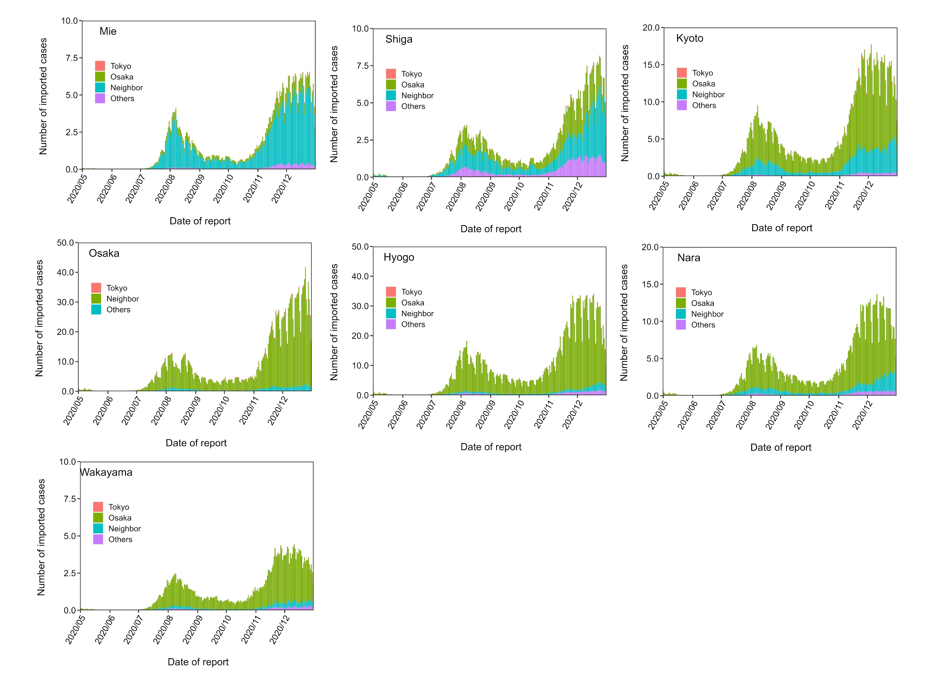
Supplementary Figure S5. Estimated number of imported cases in the Kinki region. Estimates of the number of imported cases each day from May 1 to October 31, 2020 are shown. The daily estimates are divided into four groups according to characteristics of the originating prefecture: Tokyo (red), Osaka (green), neighboring prefectures (blue), and others (purple). The Kinki region includes Mie, Shiga, Kyoto, Osaka, Hyogo, Nara and Wakayama.

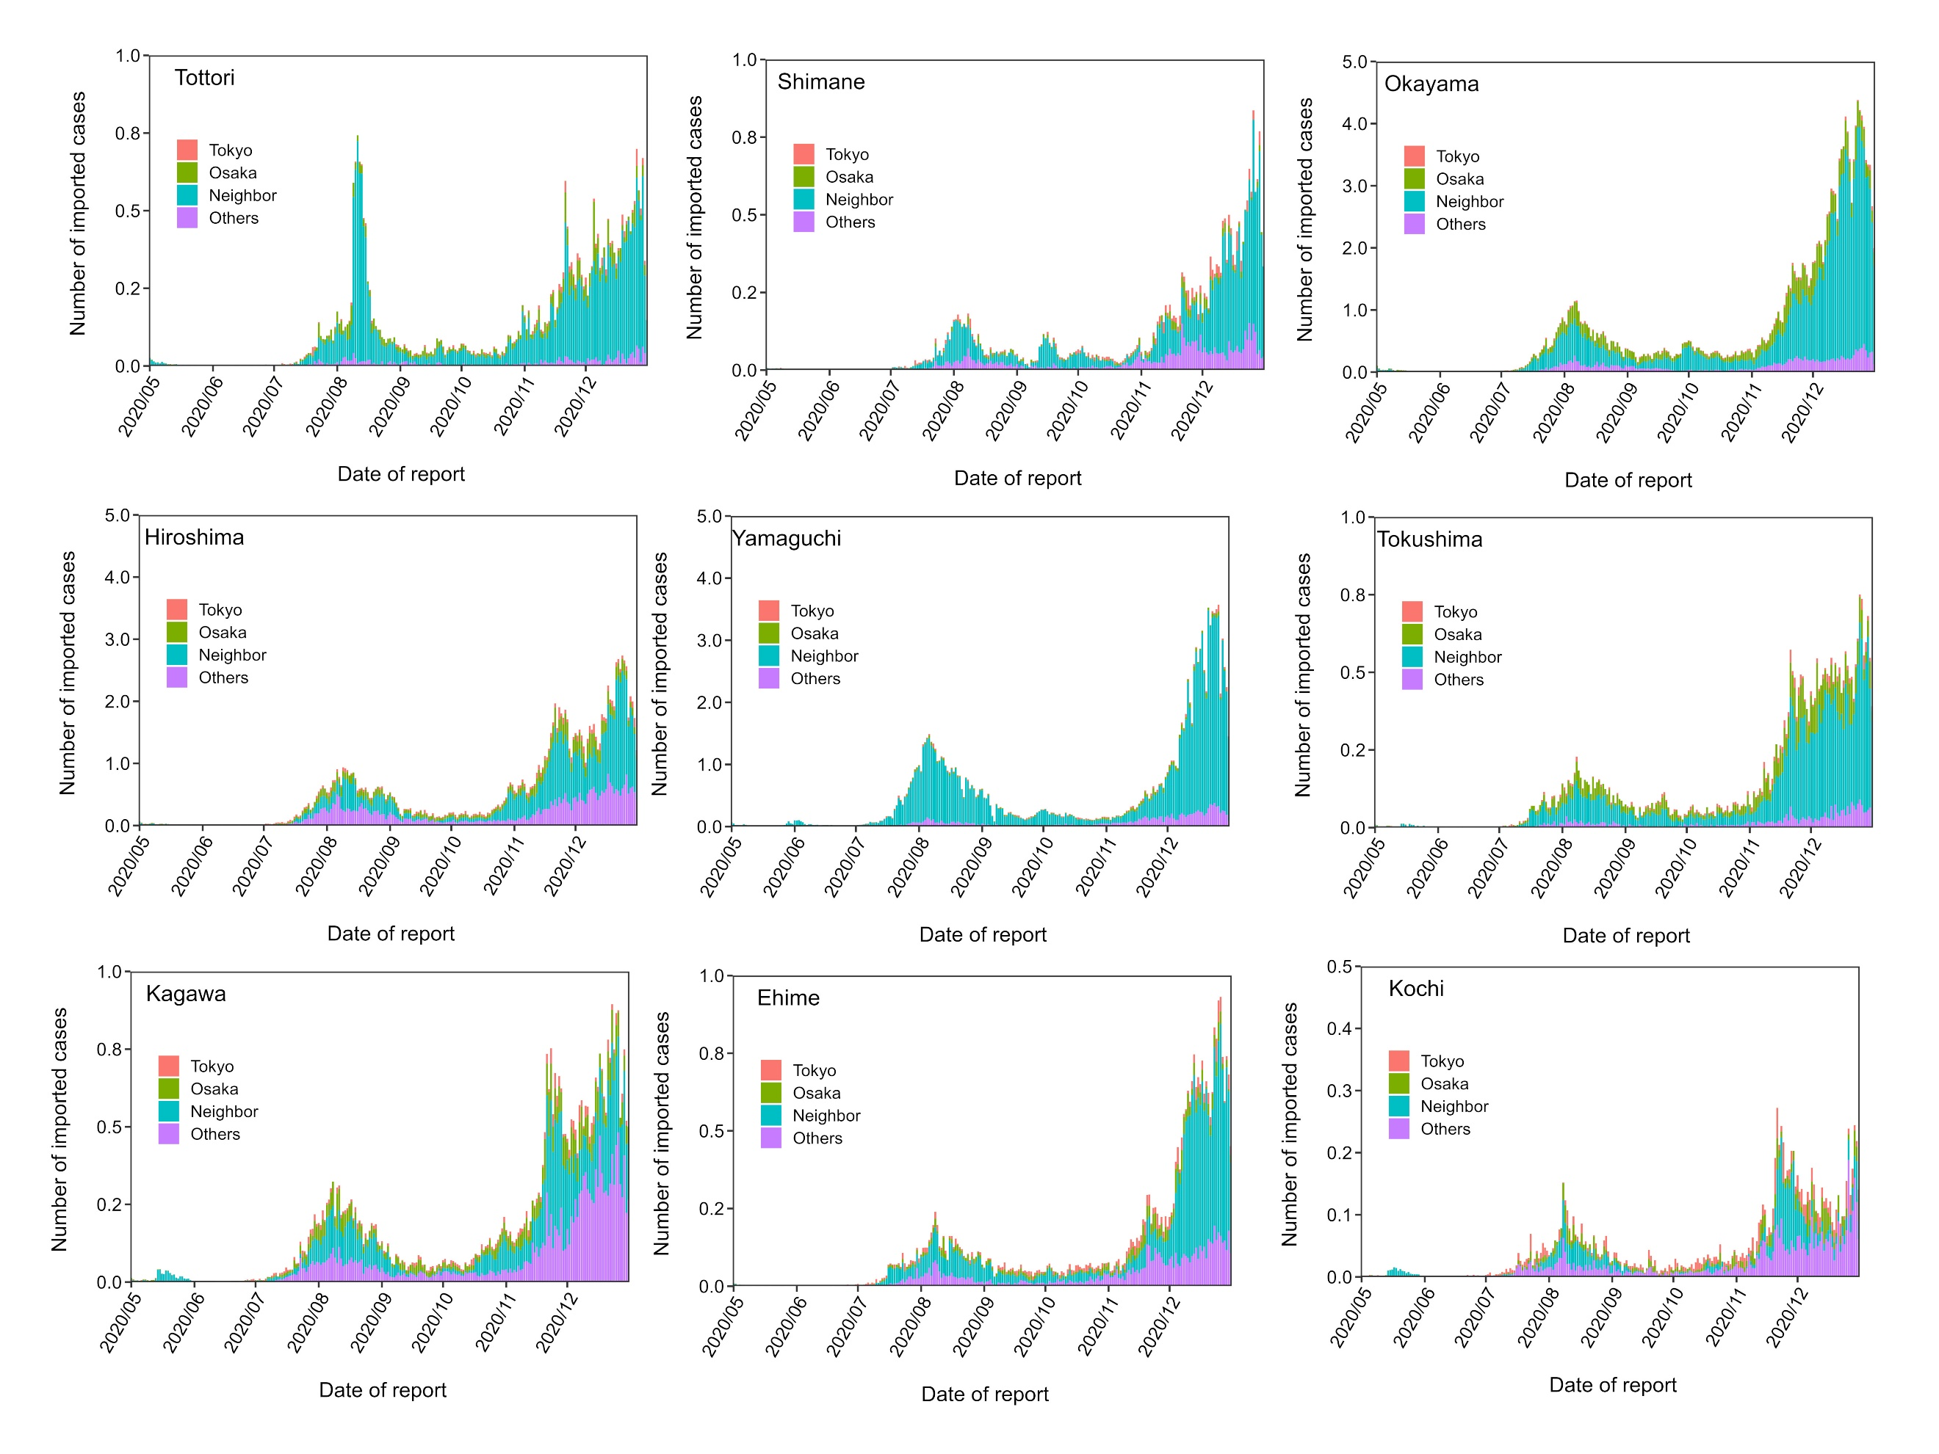
Supplementary Figure S6. Estimated number of imported cases in the Chugoku and Shikoku regions. Estimates of the number of imported cases each day from May 1 to October 31, 2020 are shown. The daily estimates are divided into four groups according to characteristics of the originating prefecture: Tokyo (red), Osaka (green), neighboring prefectures (blue), and others (purple). The Chugoku and Shikoku regions include Tottori, Shimane, Okayama, Hiroshima, Yamaguchi, Tokushima, Kagawa, Ehime and Kochi.

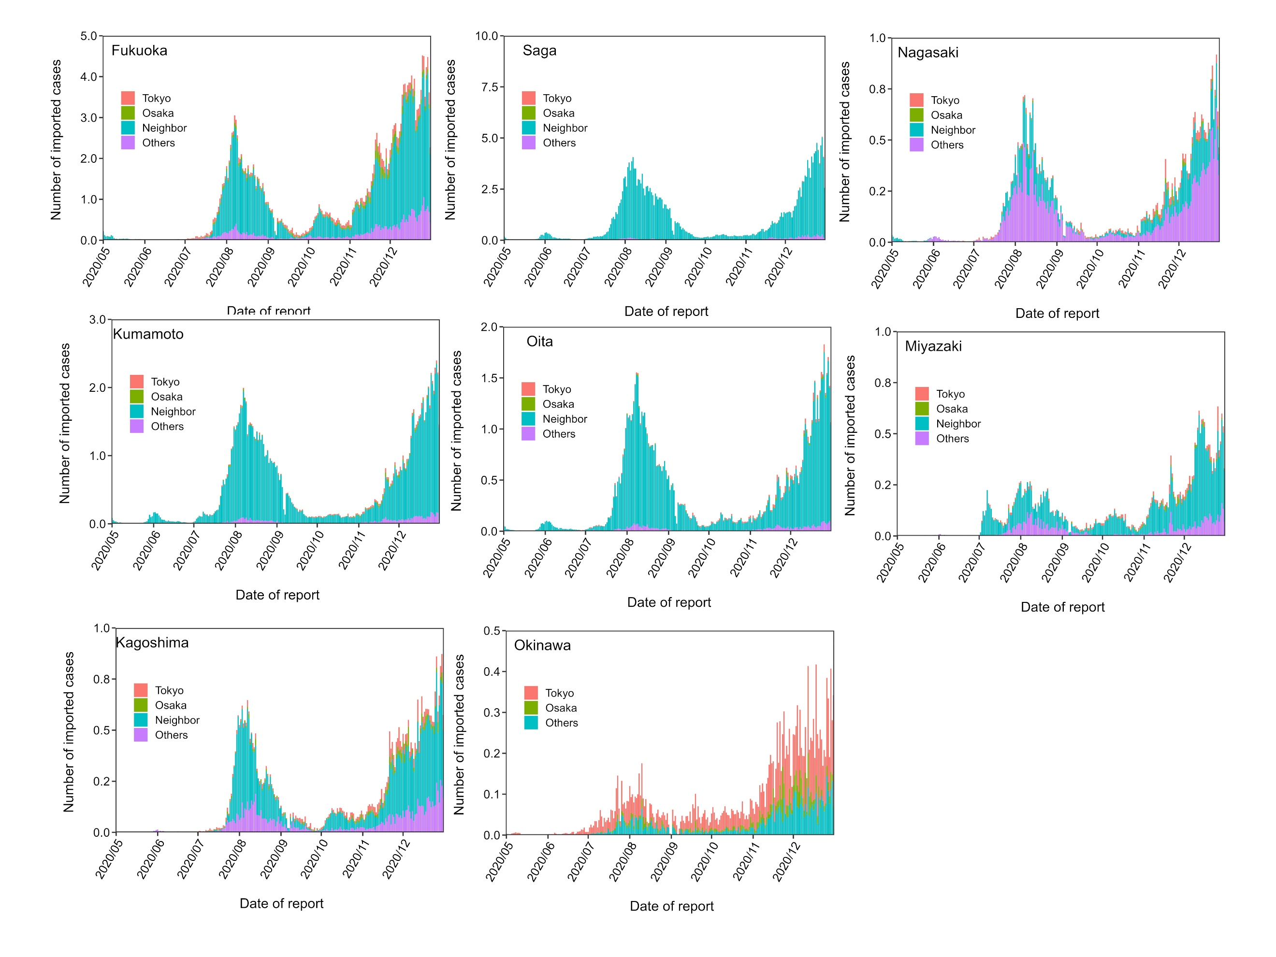
Supplementary Figure S7. Estimated number of imported cases in the Kyusyu and Okinawa regions. Estimates of the number of imported cases each day from May 1 to October 31, 2020 are shown. The daily estimates are divided into four groups according to characteristics of the originating prefecture: Tokyo (red), Osaka (green), neighboring prefectures (blue), and others (purple). The Kyusyu and Okinawa regions include Fukuoka, Saga, Nagasaki, Kumamoto, Oita, Miyazaki, Kagoshima and Okinawa.

B. Simulation with different mobility and prevalence
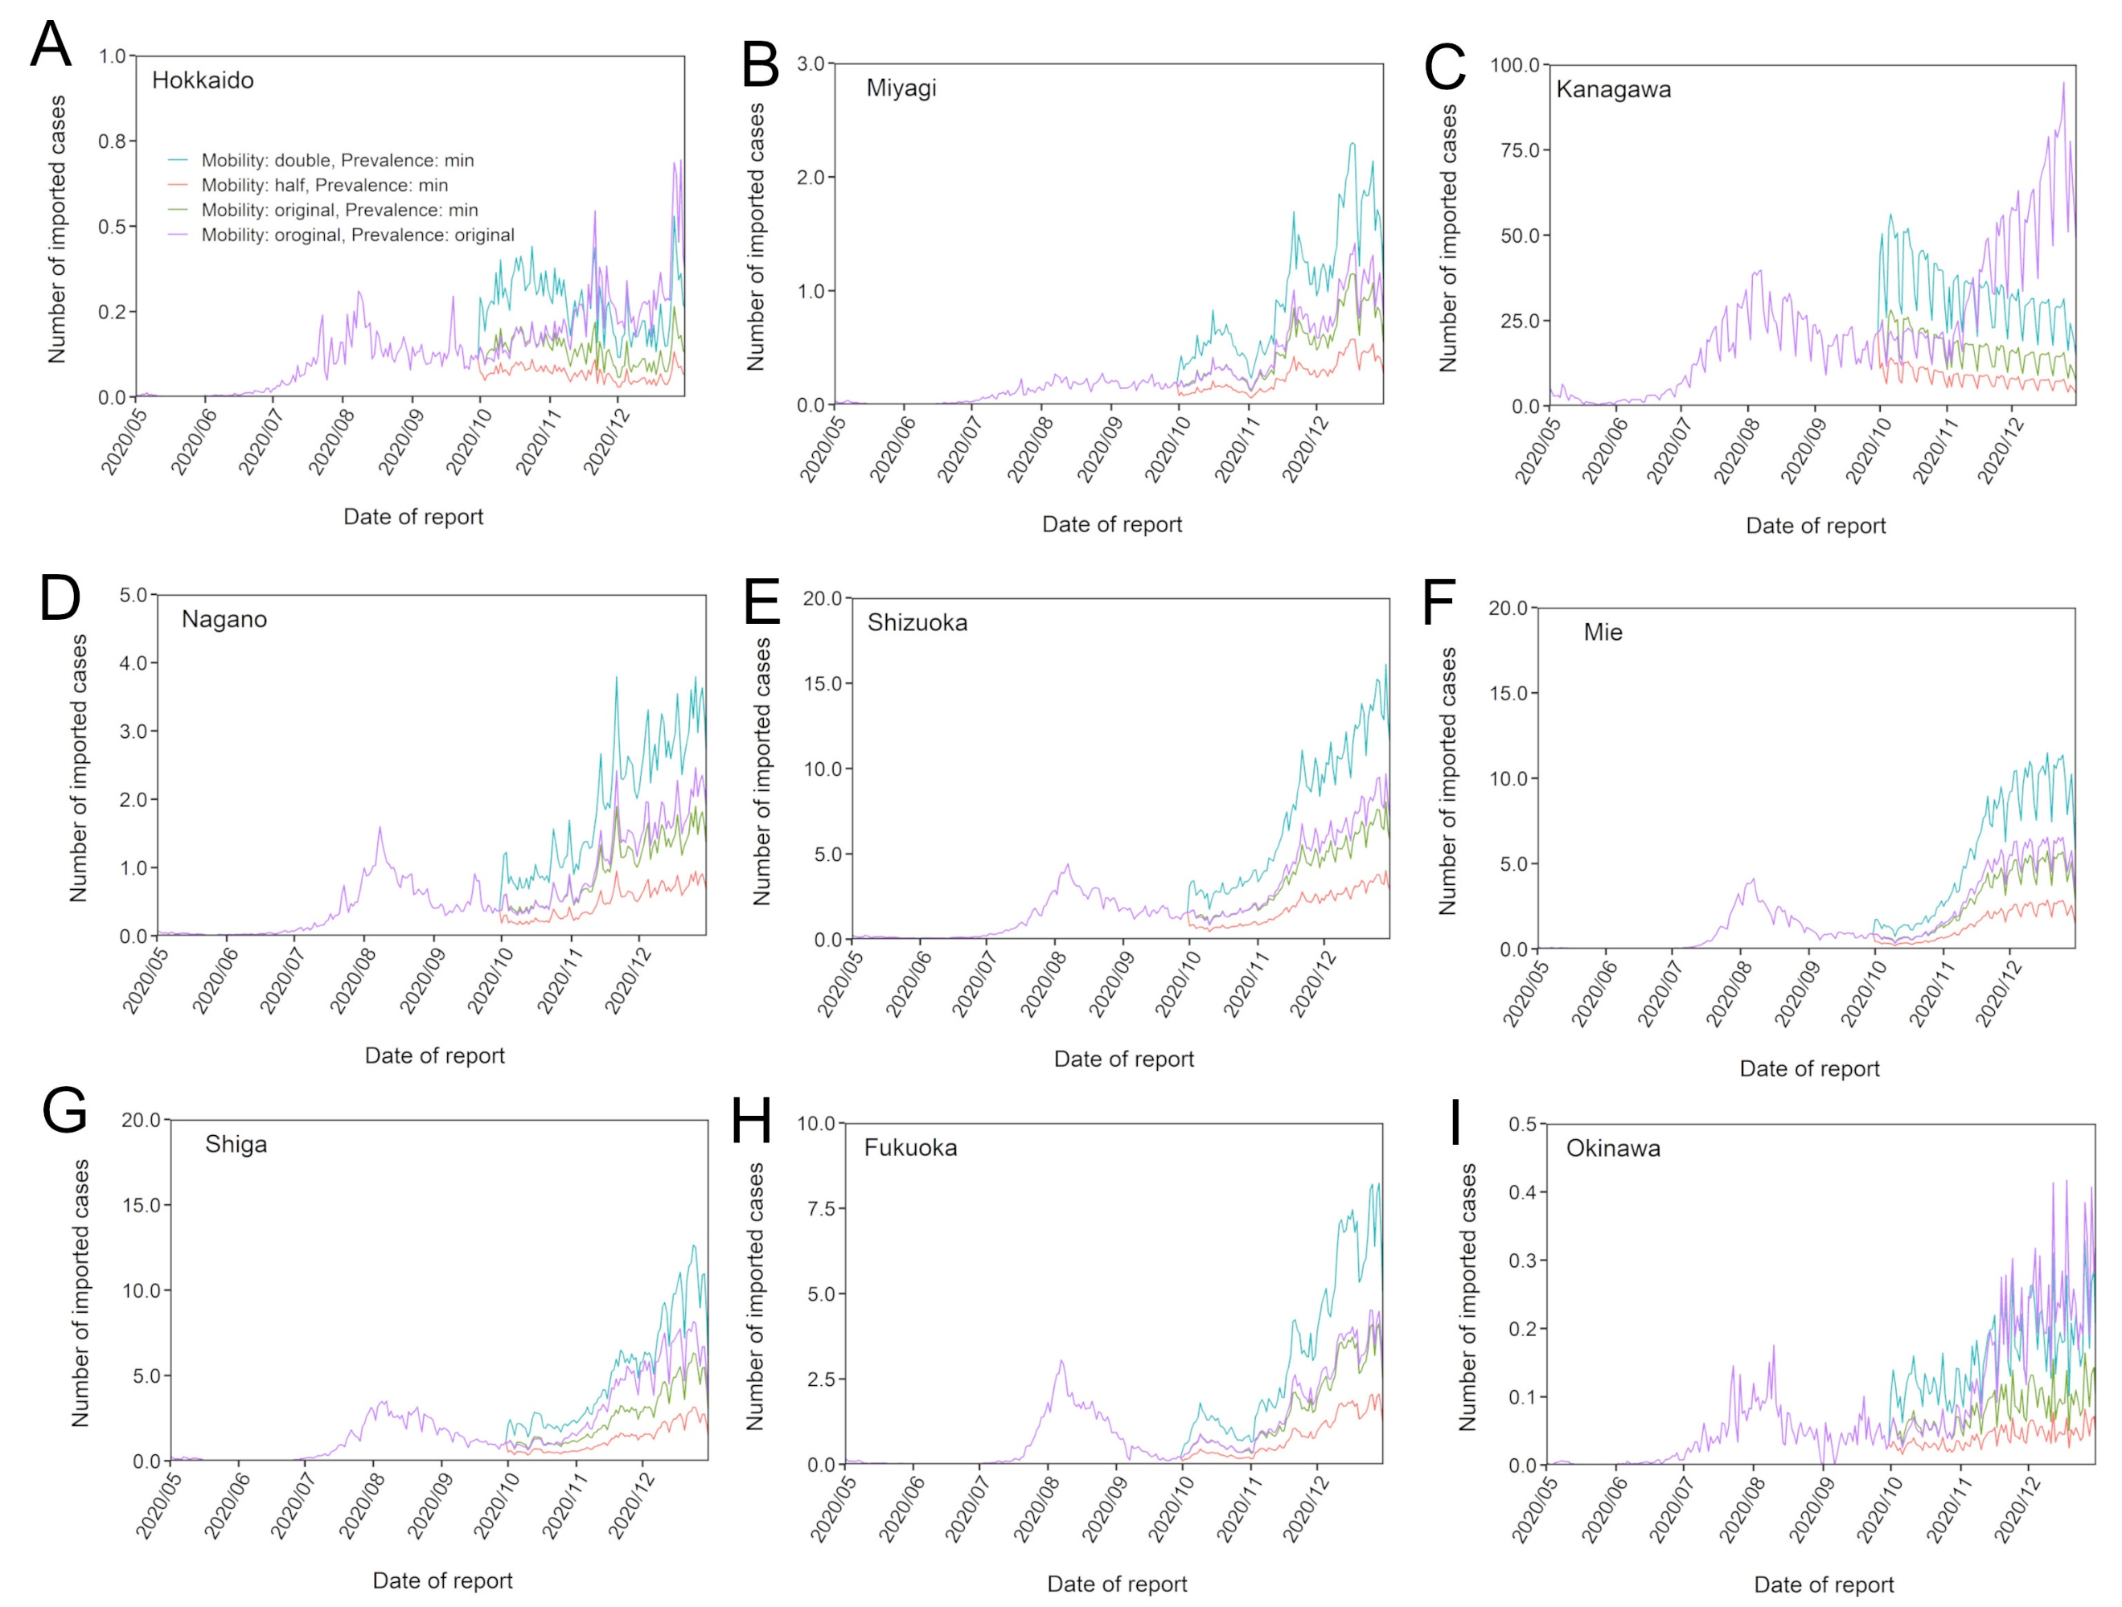
Supplementary Figure S8. Estimated number of imported cases using different mobility from all prefectures and low prevalence. Estimates of the number of imported cases each day using different mobility from all prefectures are shown. The three mobility values used were the baseline, 0.5 times the baseline, and 2.0 times the baseline. Nine prefectures (Hokkaido, Miyagi, Kanagawa, Nagano, Shizuoka, Mie, Shiga, Fukuoka, and Okinawa) were specifically selected due to their different roles (e.g. urban/rural, next to mega-prefecture and distant touristic prefecture).

