MBE, 19 (8): 8361–8379.
DOI: 10.3934/mbe.2022389
Received: 21 March 2022
Revised: 06 May 2022
Accepted: 19 May 2022
Published: 09 June 2022
http://www.aimspress.com/journal/MBE

Research article
TRPV1 is a potential biomarker for the prediction and treatment of multiple cancers based on a pan-cancer analysis
Tao Huang*
Department of Cardiothoracic Vascular Surgery, The Affiliated Hospital of Youjiang Medical University for Nationalities, Baise, China
* Correspondence: Email: huangtao_ymufm@163.com.

Supplementary
Supplementary Appendix 1. Cancers were included in the study.
The full name of cancer | Abbreviation
Adrenocortical Carcinoma | ACC
Bladder Urothelial Carcinoma | BLCA
Breast Invasive Carcinoma | BRCA
Cholangiocarcinoma | CHOL
Colon Adenocarcinoma | COAD
Lymphoid Neoplasm Diffuse Large B-Cell Lymphoma | DLBC
Esophageal Carcinoma | ESCA
Glioblastoma Multiforme | GBM
Head and Neck Squamous Cell Carcinoma | HNSCC
Kidney Chromophobe | KICH
Kidney Renal Clear Cell Carcinoma | KIRC
Kidney Renal Papillary Cell Carcinoma | KIRP
Acute Myeloid Leukemia | LAML
Brain Lower Grade Glioma | LGG
Liver Hepatocellular Carcinoma | LIHC
Lung Adenocarcinoma | LUAD
Lung Squamous Cell Carcinoma | LUSC
Mesothelioma | MESO
Ovarian Serous Cystadenocarcinoma | OV
Pancreatic Adenocarcinoma | PAAD
Pheochromocytoma and Paraganglioma | PCPG
Prostate Adenocarcinoma | PRAD
Rectum Adenocarcinoma | READ
Sarcoma | SARC
Skin Cutaneous Melanoma | SKCM
Stomach Adenocarcinoma | STAD
Testicular Germ Cell Tumors | TGCT
Thyroid Carcinoma | THCA
Thymoma | THYM
Uterine Corpus Endometrial Carcinoma | UCEC
Uterine Carcinosarcoma | UCS
Uveal Melanoma | UVM

Supplementary Appendix 2. Cancers selected in the study and their sample number.

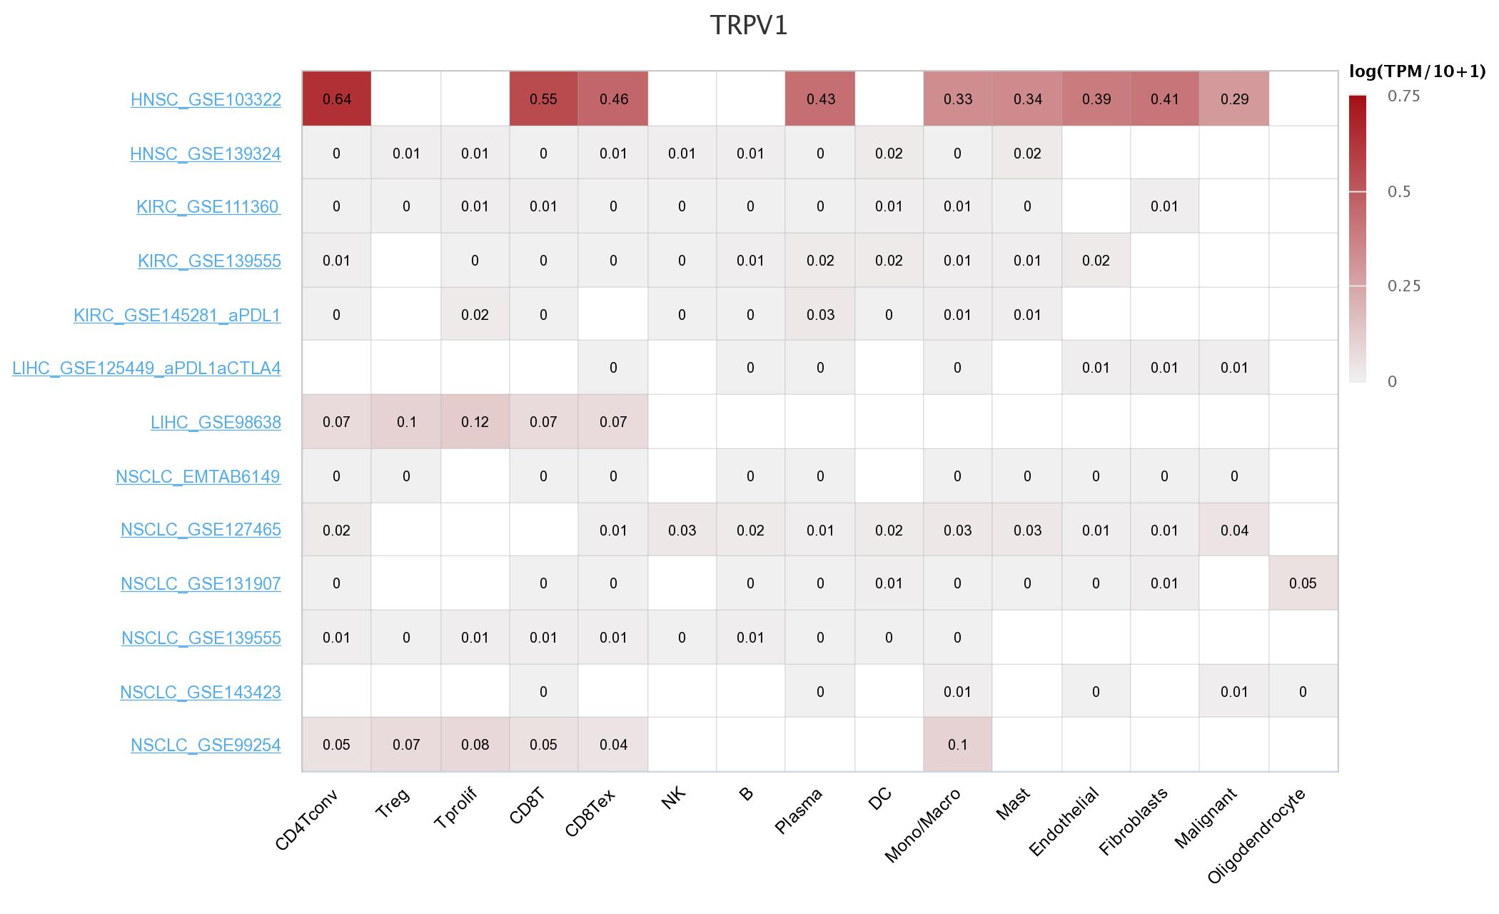
Supplementary Appendix 3. Analyses based on single cell RNA-seq data to explore cell types highly express TRPV1. The figure was obtained from Tumor Immune Single-cell Hub (http://tisch.comp-genomics.org/home/). Blank cell represents no relevant data.

Supplementary Appendix 4. Selection of possible hub genes of TRPV1 in ACC. Panel A: The clustering tree diagram indicates that specific samples (above the red line) with distinct outliers should be excluded; the remaining samples (below the red line) were utilized for subsequent analysis. Panel B: The soft threshold was set as 4. Panels C–D: Modules were determined in hierarchical clustering, of which the “brown” module had the strongest correlation with the TRPV1 expression by Pearson correlation coefficient. Panel E: A significant positive correlation between gene significance of TRPV1 expression and module membership in the “brown” module. Panel F: CDCA8 was the hub gene of the “brown” module; the network was constructed in Cytoscape with the “degree” algorithm. In Cytoscape, the visualization network was constructed based on the top 100 genes (rank by the weight values) of the “brown” module; genes not in the most extensive network are not displayed.

Supplementary Appendix 5. Selection of possible hub genes of TRPV1 in ACC. Panel A: The clustering tree diagram indicates that specific samples (above the red line) with distinct outliers should be excluded; the remaining samples (below the red line) were utilized for subsequent analysis. Panel B: The soft threshold was set as 3. Panels C–D: Modules were determined in hierarchical clustering, of which the “brown” module (except for the grey module) had the strongest correlation with the TRPV1 expression by Pearson correlation coefficient. Panel E: A significant positive correlation between gene significance of TRPV1 expression and module membership in the “brown” module. Panel F: HID1 was the hub gene of the “brown” module; the network was constructed in Cytoscape with the “degree” algorithm. In Cytoscape, the visualization network was constructed based on the top 100 genes (rank by the weight values) of the “brown” module; genes not in the most extensive network are not displayed.

Supplementary Appendix 6. Selection of possible hub genes of TRPV1 in ACC. Panel A: The clustering tree diagram indicates that specific samples (above the red line) with distinct outliers should be excluded; the remaining samples (below the red line) were utilized for subsequent analysis. Panel B: The soft threshold was set as 4. Panels C–D: Modules were determined in hierarchical clustering, of which the “yellow” module had the strongest correlation with the TRPV1 expression by Pearson correlation coefficient. Panel E: A significant positive correlation between gene significance of TRPV1 expression and module membership in the “yellow” module. Panel F: LY6G5B was the hub gene of the “yellow” module; the network was constructed in Cytoscape with the “degree” algorithm. In Cytoscape, the visualization network was constructed based on the top 100 genes (rank by the weight values) of the “yellow” module; genes not in the most extensive network are not displayed.

Supplementary Appendix 7. Selection of possible hub genes of TRPV1 in ACC. Panel A: The clustering tree diagram indicates that specific sample (above the red line) with distinct outliers should be excluded; the remaining samples (below the red line) were utilized for subsequent analysis. Panel B: The soft threshold was set as 4. Panels C–D: Modules were determined in hierarchical clustering, of which the “blue” module (except for the grey module) had the strongest correlation with the TRPV1 expression by Pearson correlation coefficient. Panel E: A significant positive correlation between gene significance of TRPV1 expression and module membership in the “blue” module. Panel F: EFR3B, TMSB15B, and EFS were the hub gene of the “blue” module; the network was constructed in Cytoscape with the “degree” algorithm. In Cytoscape, the visualization network was constructed based on the top 100 genes (rank by the weight values) of the “blue” module; genes not in the most extensive network are not displayed.

Supplementary Appendix 8. Correlation between TRPV1 expression level and IC50 of drugs with a p-value less than 0.01.
Drug | Spearman Correlation Coefficient | p-value
I-BET-762 | -0.461 | <0.001
INCB-057643 | -0.388 | 0.003
DOLASTATIN 10 | -0.364 | 0.005
AEW-541 | -0.358 | 0.006
ABBV-075 | -0.348 | 0.008
OTX-015 | -0.335 | 0.011
ADW-742 | -0.335 | 0.011
Bet-BAY-002 | -0.331 | 0.012
AMG-51 | -0.329 | 0.013
Selumetinib | -0.328 | 0.013
Defactinib | -0.328 | 0.013
BMS-986158 | -0.328 | 0.013
AZD-5153 | -0.315 | 0.017
HPI-1 | -0.313 | 0.018
GSK-2194069 | -0.304 | 0.022
ARRY-162 | -0.303 | 0.022
Cs-1730 | -0.303 | 0.022
I-BET-151 | -0.301 | 0.023
PYRAZOLOACRIDINE | 0.298 | 0.024
Dabrafenib | -0.296 | 0.025
Sulfatinib | -0.294 | 0.027
PFI-1 | -0.290 | 0.028
ABBV-744 | -0.288 | 0.030
JNJ-28312141 | -0.288 | 0.030
Cyclophosphamide | -0.279 | 0.036
RG-7602 | -0.278 | 0.037
CEP-9722 | 0.275 | 0.039
ST-3595 | 0.274 | 0.039
Tandutinib | -0.273 | 0.040
Adavosertib | -0.269 | 0.043
Ensartinib | -0.268 | 0.044
CH-7057288 | -0.267 | 0.045
Refametinib | -0.264 | 0.048
Bafetinib | -0.263 | 0.048

