MBE, 19(9): 9481–9504.
DOI: 10.3934/mbe.2022441
Received: 03 April 2022
Revised: 08 June 2022
Accepted: 20 June 2022
Published: 29 June 2022
http://www.aimspress.com/journal/MBE

Research article
A novel defined risk signature of interferon response genes predicts the prognosis and correlates with immune infiltration in glioblastoma
Yong Xiao^{1,2,}†, Zhen Wang^{1,2,}†, Mengjie Zhao², Wei Ji^{1,3}, Chong Xiang^{1,4}, Taiping Li², Ran Wang^{1,2}, Kun Yang¹, Chunfa Qian¹, Xianglong Tang², Hong Xiao², Yuanjie Zou^{1,}* and Hongyi Liu^{1,}*
¹ Department of Neurosurgery, Nanjing Brain Hospital Affiliated to Nanjing Medical University, Nanjing, China
² Department of Neuro-Psychiatric Institute, Nanjing Brain Hospital Affiliated to Nanjing Medical University, Nanjing, China
³ Department of Neurosurgery, Wuxi People’s Hospital of Nanjing Medical University, Wuxi, China
⁴ Department of Neurosurgery, Changzhou Wujin People’s Hospital, Changzhou, China
† The authors contributed equally to this work.
* Correspondence: Email: zouyuanjie0115@126.com, njnkyylhy@163.com.

Supplementary
Table S1. 10 interferon response gene sets.
GOBP_CELLULAR_RESPONSE_TO_INTERFERON_ALPHA | http://www.gsea-msigdb.org/gsea/msigdb/cards/GOBP_CELLULAR_RESPONSE_TO_INTERFERON_ALPHA.html
GOBP_CELLULAR_RESPONSE_TO_INTERFERON_BETA | http://www.gsea-msigdb.org/gsea/msigdb/cards/GOBP_CELLULAR_RESPONSE_TO_INTERFERON_BETA.html
GOBP_REGULATION_OF_RESPONSE_TO_INTERFERON_GAMMA | http://www.gsea-msigdb.org/gsea/msigdb/cards/GOBP_REGULATION_OF_RESPONSE_TO_INTERFERON_GAMMA.html
GOBP_RESPONSE_TO_INTERFERON_ALPHA | http://www.gsea-msigdb.org/gsea/msigdb/cards/GOBP_RESPONSE_TO_INTERFERON_ALPHA.html
 | Continued on next page
GOBP_RESPONSE_TO_INTERFERON_BETA | http://www.gsea-msigdb.org/gsea/msigdb/cards/GOBP_RESPONSE_TO_INTERFERON_BETA.html
GOBP_RESPONSE_TO_INTERFERON_GAMMA | http://www.gsea-msigdb.org/gsea/msigdb/cards/GOBP_RESPONSE_TO_INTERFERON_GAMMA.html
HALLMARK_INTERFERON_ALPHA_RESPONSE | http://www.gsea-msigdb.org/gsea/msigdb/cards/HALLMARK_INTERFERON_ALPHA_RESPONSE.html
HALLMARK_INTERFERON_GAMMA_RESPONSE | http://www.gsea-msigdb.org/gsea/msigdb/cards/HALLMARK_INTERFERON_GAMMA_RESPONSE.html
NATSUME_RESPONSE_TO_INTERFERON_BETA_DN | http://www.gsea-msigdb.org/gsea/msigdb/cards/NATSUME_RESPONSE_TO_INTERFERON_BETA_DN.html
NATSUME_RESPONSE_TO_INTERFERON_BETA_UP | http://www.gsea-msigdb.org/gsea/msigdb/cards/NATSUME_RESPONSE_TO_INTERFERON_BETA_UP.html
Table S2. 54 interferons with uni-cox survival value.
gene | HR | HR.95L | HR.95H | p-value
ACTR3 | 1.13461 | 1.00553 | 1.28025 | 0.04041
ANXA2 | 1.1065 | 1.0309 | 1.18763 | 0.00506
APOL6 | 1.21416 | 1.02795 | 1.43409 | 0.02234
BANK1 | 1.40799 | 1.01334 | 1.95634 | 0.04145
BCL3 | 1.12197 | 1.01465 | 1.24065 | 0.02487
C1R | 1.10001 | 1.02041 | 1.18582 | 0.01287
C1S | 1.10646 | 1.01575 | 1.20528 | 0.02045
CCL19 | 0.85667 | 0.74548 | 0.98445 | 0.02919
CCL2 | 1.0797 | 1.01292 | 1.15088 | 0.01858
CD44 | 1.12817 | 1.04214 | 1.22129 | 0.00288
CDK13 | 1.23636 | 1.01236 | 1.50992 | 0.03748
CIITA | 1.15601 | 1.0069 | 1.3272 | 0.03963
EPHB3 | 1.13317 | 1.01455 | 1.26566 | 0.02669
TENT5A | 1.1665 | 1.0259 | 1.32636 | 0.01876
FAS | 1.16517 | 1.02573 | 1.32355 | 0.01874
GBP1 | 1.12815 | 1.03452 | 1.23026 | 0.00638
GRB14 | 1.16258 | 1.04392 | 1.29474 | 0.0061
HELZ2 | 1.16132 | 1.01863 | 1.32401 | 0.02535
HPX | 1.18004 | 1.00063 | 1.39163 | 0.04914
ICAM1 | 1.13991 | 1.03684 | 1.25323 | 0.00677
IFNGR2 | 1.16758 | 1.00315 | 1.35897 | 0.04544
IGFBP3 | 1.07542 | 1.00991 | 1.14518 | 0.02336
IGFBP5 | 1.17496 | 1.07657 | 1.28233 | 0.0003
IRF1 | 1.12727 | 1.00188 | 1.26835 | 0.04646
IRF2 | 1.17427 | 1.01123 | 1.36359 | 0.03517
KDM5A | 1.17292 | 1.00253 | 1.37227 | 0.04643
LATS2 | 1.40644 | 1.15388 | 1.71427 | 0.00073
 |  |  |  | Continued on next page
gene | HR | HR.95L | HR.95H | p-value
MAP3K14 | 1.21322 | 1.04603 | 1.40714 | 0.01063
METTL7B | 1.09782 | 1.01987 | 1.18173 | 0.013
MMP2 | 1.12567 | 1.02111 | 1.24095 | 0.01732
MYD88 | 1.17688 | 1.03075 | 1.34373 | 0.01605
NAMPT | 1.09404 | 1.01254 | 1.1821 | 0.02288
NFKB1 | 1.21307 | 1.01585 | 1.44858 | 0.03287
NLRC5 | 1.12868 | 1.0075 | 1.26444 | 0.03672
NR1H4 | 0.39009 | 0.19755 | 0.77027 | 0.00669
PARP14 | 1.1575 | 1.00178 | 1.33743 | 0.04725
PARP9 | 1.15368 | 1.02454 | 1.2991 | 0.01826
PDGFA | 1.15105 | 1.02447 | 1.29328 | 0.01795
PTPRZ1 | 1.09817 | 1.01079 | 1.1931 | 0.02684
SAMD9L | 1.16668 | 1.03761 | 1.31182 | 0.00997
SELL | 0.84209 | 0.74728 | 0.94891 | 0.0048
SLC11A1 | 1.13712 | 1.04531 | 1.237 | 0.00278
SOCS3 | 1.12503 | 1.04765 | 1.20813 | 0.00119
SOD2 | 1.11762 | 1.03075 | 1.21181 | 0.00707
STAR | 0.72737 | 0.57563 | 0.91912 | 0.00767
STAT2 | 1.18473 | 1.02929 | 1.36364 | 0.01816
STAT3 | 1.2824 | 1.10195 | 1.49241 | 0.00131
TNFAIP3 | 1.15164 | 1.02461 | 1.29441 | 0.0179
TNFAIP6 | 1.1049 | 1.00411 | 1.21582 | 0.04095
TNFSF14 | 1.28738 | 1.10872 | 1.49483 | 0.00092
TOR1B | 1.18826 | 1.00253 | 1.40841 | 0.04669
TRIM14 | 1.26632 | 1.06828 | 1.50106 | 0.0065
VIM | 1.16502 | 1.0639 | 1.27574 | 0.00098
XCL1 | 1.7696 | 1.00369 | 3.11998 | 0.04853
Table S3. Top 30 nodes in protein-protein interaction network based on 54 genes.
Rank | Name | Score
1 | STAT3 | 20
2 | CD44 | 17
2 | CCL2 | 17
2 | ICAM1 | 17
2 | IRF1 | 17
6 | NFKB1 | 12
6 | MYD88 | 12
8 | TNFAIP3 | 11
8 | SOCS3 | 11
8 | STAT2 | 11
11 | MMP2 | 10
 |  | Continued on next page
Rank | Name | Score
11 | GBP1 | 10
13 | IRF2 | 9
13 | CIITA | 9
15 | SELL | 7
15 | SOD2 | 7
17 | TRIM14 | 6
17 | CCL19 | 6
17 | PARP9 | 6
20 | IFNGR2 | 5
20 | BCL3 | 5
20 | PARP14 | 5
20 | FAS | 5
24 | ANXA2 | 4
24 | VIM | 4
24 | SAMD9L | 4
24 | HELZ2 | 4
24 | MAP3K14 | 4
29 | IGFBP3 | 3
29 | XCL1 | 3
Table S4. Meta-analysis of 10 core interferon response genes prognostic value.
GENE | DATASET | CANCER TYPE | ENDPOINT | N | CUTPOINT | COX P-VALUE | HR [95% CI-low CI-upp]
CD44 | GSE4412-GPL97 | Glioma | Overall Survival | 74 | 0.824324 | 0.000315634 | 2.14 [1.41–3.23]
MYD88 | MGH-glioma | Glioma | Overall Survival | 50 | 0.72 | 0.0123751 | 1.74 [1.13–2.68]
STAT2 | MGH-glioma | Glioma | Overall Survival | 50 | 0.88 | 0.0178092 | 7.49 [1.42–39.59]
TNFAIP3 | MGH-glioma | Glioma | Overall Survival | 50 | 0.7 | 0.0183943 | 1.52 [1.07–2.16]
SOCS3 | GSE4412-GPL97 | Glioma | Overall Survival | 74 | 0.189189 | 0.0228091 | 1.26 [1.03–1.54]
NFKB1 | MGH-glioma | Glioma | Overall Survival | 50 | 0.84 | 0.0334134 | 3.54 [1.10–11.32]
STAT3 | GSE4412-GPL97 | Glioma | Overall Survival | 74 | 0.418919 | 0.0668225 | 2.37 [0.94–5.97]
ICAM1 | GSE4412-GPL96 | Glioma | Overall Survival | 74 | 0.391892 | 0.0699967 | 1.66 [0.96–2.88]
CCL2 | MGH-glioma | Glioma | Overall Survival | 50 | 0.22 | 0.176027 | 1.12 [0.95–1.31]
IRF1 | GSE4412-GPL96 | Glioma | Overall Survival | 74 | 0.459459 | 0.302895 | 1.42 [0.73–2.79]
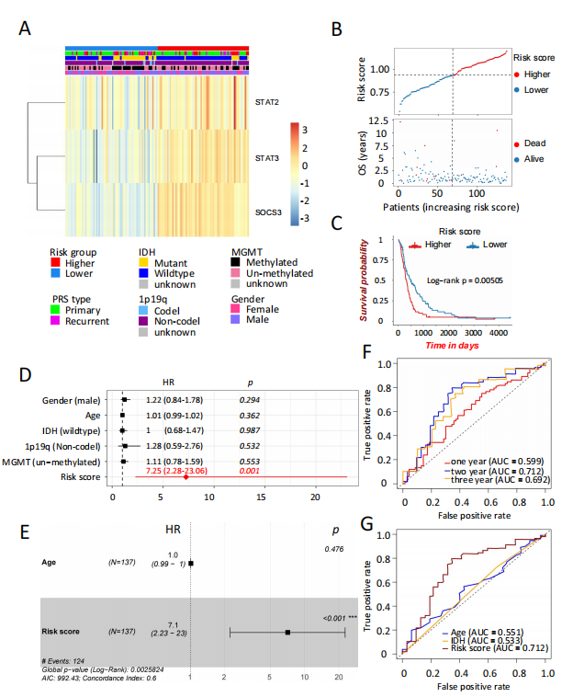
Figure S1. Validation of risk model for GBM patients in CGGA cohort 2. (A) Heatmap of 3 risk signatures expression among the higher and lower risk GBM subgroups together with clinicopathological features. Higher risk group had relative higher expression of STAT2, STAT3 and SOCS3. (B) Risk score distribution together with survival status for GBM patients. (C) Survival analysis for the OS of GBM patients in the higher and lower risk subgroups based on risk score. Higher group confronted poor prognosis than the lower one. Uni-variate (D) and multi-variate (E) Cox regression analysis of the association between risk score, clinicopathological features and patient OS revealed the risk score was an independent factor for GBM patient survival. (F) ROC curves presented the predictive efficiency. (G) Multi-indicator ROC curves for risk score, age and IDH state. Risk score was a better predictor than others for GBM survival.
© 2022 the Author(s), licensee AIMS Press. This is an open access article distributed under the terms of the Creative Commons Attribution License (http://creativecommons.org/licenses/by/4.0)

