MBE, 18(6): 8084–8095.
DOI: 10.3934/mbe.2021401
Received: 21 July 2021
Accepted: 09 September 2021
Published: 16 September 2021
http://www.aimspress.com/journal/MBE

Research article
Development of a nomograph integrating radiomics and deep features based on MRI to predict the prognosis of high grade Gliomas
Yutao Wang ¹, Qian Shao ^{2,}*, Shuying Luo ² and Randi Fu ²
¹ Affiliated Hospital of Medical School, Ningbo University, Ningbo 315020, China
² Faculty of Electrical Engineering and Computer Science, Ningbo University, Ningbo 315211, China
* Correspondence: Email: 243386393@qq.com; Tel: +8618758390460.

Appendix
Appendix A1
Appendix A1 contains the 107 radiomics features that were extracted using PyRadiomics. They are subdivided into the following classes:
First Order Statistics (18 features)
1. 10Percentile
2. 90Percentile
3. Energy
4. Entropy
5. Interquartile Range
6. Kurtosis
7. Maximum
8. Mean Absolute Deviation
9. Mean
10. Median
11. Minimum
12. Range
13. Robust Mean Absolute Deviation
14. Root Mean Squared
15. Skewness
16. Total Energy
17. Uniformity
18. Variance

Shape-based (2D and 3D) (14 features)
1. Major Axis Length
2. Minor Axis Length
3. Elongation
4. Mesh Volume
5. Voxel Volume
6. Surface Area
7. Sphericity
8. Maximum2DDiameter (Slice)
9. Maximum2DDiameter (Column)
10. Maximum2DDiameter (Row)
11. Maximum3DDiameter
12. Flatness
13. Least Axis Length
14. Surface Volume Ratio

Gray Level Co-occurrence Matrix (24 features)
1. Autocorrelation
2. Cluster Prominence
3. Cluster Shade
4. Cluster Tendency
5. Contrast
6. Correlation
7. Difference Average
8. Difference Entropy
9. Difference Variance
10. Inverse Difference
11. Inverse Difference Moment
12. Inverse Difference Moment Normalized
13. Inverse Difference Normalized
14. Informational Measure of Correlation 1
15. Informational Measure of Correlation 2
16. Inverse Variance
17. Joint Average
18. Joint Energy
19. Joint Entropy
20. Maximal Correlation Coefficient
21. Maximum Probability
22. Sum Average
23. Sum Entropy
24. Sum Squares

Gray Level Run Length Matrix (16 features)
1. Gray Level Non-Uniformity
2. Gray Level Non-Uniformity Normalized
3. Gray Level Variance
4. High Gray Level Run Emphasis
5. Long Run Emphasis
6. Long Run High Gray Level Emphasis
7. Long Run Low Gray Level Emphasis
8. Low Gray Level Run Emphasis
9. Run Entropy
10. Run Length Non-Uniformity
11. Run Length Non-Uniformity Normalized
12. Run Percentage
13. Run Variance
14. Short Run Emphasis
15. Short Run High Gray Level Emphasis
16. Short Run Low Gray Level Emphasis
Gray Level Size Zone Matrix (16 features)
1. Gray Level Non-Uniformity
2. Gray Level Non-Uniformity Normalized
3. Gray Level Variance
4. High Gray Level Zone Emphasis
5. Large Area Emphasis
6. Large Area High Gray Level Emphasis
7. Large Area Low Gray Level Emphasis
8. Low Gray Level Zone Emphasis
9. Size Zone Non-Uniformity
10. Size Zone Non-Uniformity Normalized
11. Small Area Emphasis
12. Small Area High Gray Level Emphasis
13. Small Area Low Gray Level Emphasis
14. Zone Entropy
15. Zone Percentage
16. Zone Variance
Neighbouring Gray Tone Difference Matrix (5 features)
1. Busyness
2. Coarseness
3. Complexity
4. Contrast
5. Strength

Gray Level Dependence Matrix (14 features)
1. Dependence Entropy
2. Dependence Non-Uniformity
3. Dependence Non-Uniformity Normalized
4. Dependence Variance
5. Gray Level Non-Uniformity
6. Gray Level Variance
7. High Gray Level Emphasis
8. Large Dependence Emphasis
9. Large Dependence High Gray Level Emphasis
10. Large Dependence Low Gray Level Emphasis
11. Low Gray Level Emphasis
12. Small Dependence Emphasis
13. Small Dependence High Gray Level Emphasis
14. Small Dependence Low Gray Level Emphasis
Appendix A2
Kernel size of each layer of 3D-ResNet50.
layer name | 3D-ResNet50
conv1 | 7×7×7, 64, stride 2
conv2_x | 3×3×3 max pool, stride 2
 | $$\left[\begin{matrix}1×1×1, & 64 \\ 3×3×3, & 64 \\ 1×1×1, & 256\end{matrix}\right]×3$$
conv3_x | $$\left[\begin{matrix}1×1×1, & 128 \\ 3×3×3, & 128 \\ 1×1×1, & 512\end{matrix}\right]×4$$
conv4_x | $$\left[\begin{matrix}1×1×1, & 256 \\ 3×3×3, & 256 \\ 1×1×1, & 1024\end{matrix}\right]×6$$
conv5_x | $$\left[\begin{matrix}1×1×1, & 512 \\ 3×3×3, & 512 \\ 1×1×1, & 2048\end{matrix}\right]×3$$
max pooling | max pool, 2048-d fc
1×1×1, 3×3×3 and 7×7×7 in the table are the size of the convolution kernel; 64, 128, 256, 1024 and 2048 are the number of channels output after each convolution; The network structure contained in each square bracket is a “bottleneck” building block，take conv3_x for example as shown in Fig. 1.

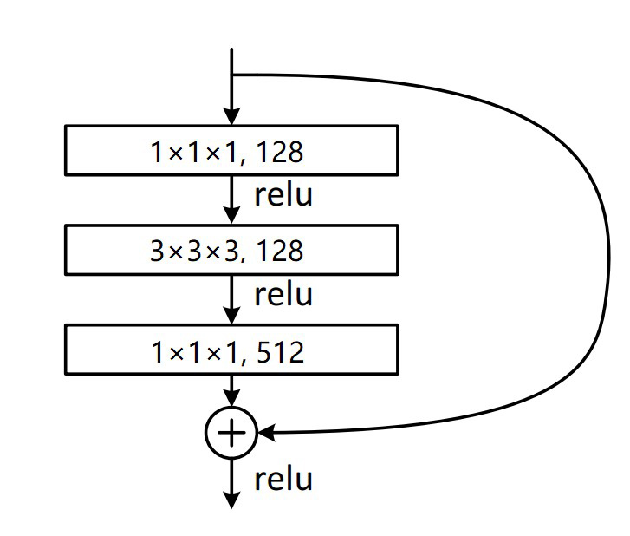
Figure 1. A “bottleneck” building block for 3D-ResNet50. Bottleneck is designed to reduce the number of parameters. Considering the cost of calculation, the calculation of the residual block is optimized, that is, the convolutional layer is designed to be 1x1x1 + 3x3x3 + 1x1x1. First, the dimension is reduced by the convolution kernel of 1x1x1, and the result is input to the intermediate layer, and then restored under the convolutional layer of 1x1x1, which not only maintains the accuracy but also reduces the amount of calculation. The first 1x1x1 convolution reduces the 512-dimensional channel to 128 dimensions, and then recovers the 512 dimensions by 1x1x1 convolution at the end.
Appendix A3
The details of the R-packages used in the research
1. Formula:
Description Infrastructure for extended formulas with multiple parts on the right-hand side and/or multiple responses on the left-hand side (see).
Depends R (>= 2.0.0), stats
License GPL-2 | GPL-3
NeedsCompilation no

2. ggplot2:
Description
A system for 'declaratively' creating graphics, based on ``The Grammar of Graphics''. You provide the data, tell 'ggplot2' how to map variables to aesthetics, what graphical primitives to use, and it takes care of the details.
Depends R (>= 3.2)
Imports digest, glue, grDevices, grid, gtable (>= 0.1.1), isoband, MASS, mgcv, rlang (>= 0.3.0), scales (>= 0.5.0), stats, tibble, withr (>= 2.0.0)
Suggests covr, dplyr, ggplot2movies, hexbin, Hmisc, knitr, lattice, mapproj, maps, maptools, multcomp, munsell, nlme, profvis, quantreg, RColorBrewer, rgeos, rmarkdown, rpart, sf (>= 0.7-3), svglite (>= 1.2.0.9001), testthat (>= 2.1.0), vdiffr (>= 0.3.0)
Enhances sp
License GPL-2 | file LICENSE

3. glmnet:
Description Extremely efficient procedures for fitting the entire lasso or elastic-net regularization path for linear regression, logistic and multinomial regression models, Poisson regression, Cox model, multiple-response Gaussian, and the grouped multinomial regression. There are two new and important additions. The family argument can be a GLM family object, which opens the door to any programmed family. This comes with a modest computational cost, so when the built-in families suffice, they should be used instead. The other novelty is the relax option, which refits each of the active sets in the path unpenalized. The algorithm uses cyclical coordinate descent in a path-wise fashion, as described in the papers listed in the URL below.
Depends R (>= 3.6.0), Matrix (>= 1.0-6)
Imports methods, utils, foreach, shape, survival
Suggests knitr, lars, testthat
License GPL-2
VignetteBuilder knitr
Encoding UTF-8

4. grid:
Description grid adds an nx by ny rectangular grid to an existing plot.

5. Hmisc:
Description Contains many functions useful for data analysis, high-level graphics, utility operations, functions for
computing sample size and power, importing and annotating datasets, imputing missing values, advanced table making, variable clustering, character string manipulation, conversion of R objects to LaTeX and html code,
and recoding variables.
Depends lattice, survival (>= 3.1-6), Formula, ggplot2 (>= 2.2)
Imports methods, latticeExtra, cluster, rpart, nnet, foreign, gtable, grid, gridExtra, data.table, htmlTable (>= 1.11.0), viridis, htmltools, base64enc
Suggests acepack, chron, rms, mice, tables, knitr, plotly (>= 4.5.6), rlang, plyr
License GPL (>= 2)
LazyLoad Yes

6. lattice:
Description A powerful and elegant high-level data visualization system inspired by Trellis graphics, with an emphasis on multivariate data. Lattice is sufficient for typical graphics needs, and is also flexible enough to handle most nonstandard requirements.
Depends R (>= 3.0.0)
Imports grid, grDevices, graphics, stats, utils
Suggests KernSmooth, MASS, latticeExtra
Enhances chron
LazyLoad yes
LazyData yes
License GPL (>= 2)

7. rms:
Description Regression modeling, testing, estimation, validation, graphics, prediction, and typesetting by storing enhanced model design attributes in the fit. 'rms' is a collection of functions that assist with and streamline modeling. It also contains functions for binary and ordinal logistic regression models, ordinal models for continuous Y with a variety of distribution families, and the Buckley-James multiple regression model for right-censored responses, and implements penalized maximum likelihood estimation for logistic and ordinary linear models. 'rms' works with almost any regression model, but it was especially written to work with binary or ordinal regression models, Cox regression, accelerated failure time models, ordinary linear models,the Buckley-James model, generalized least squares for serially or spatially correlated observations, generalized linear models, and quantile regression.
Depends R (>= 3.5.0), Hmisc (>= 4.3-0), survival (>= 3.1-12), lattice, ggplot2 (>= 2.2), SparseM
Imports methods, quantreg, rpart, nlme (>= 3.1-123), polspline, multcomp, htmlTable (>= 1.11.0), htmltools, MASS, cluster, digest
Suggests boot, tcltk, plotly (>= 4.5.6), knitr, mice, rmsb
License GPL (>= 2)

8. survival:
Description Contains the core survival analysis routines, including definition of Surv objects, Kaplan-Meier and Aalen-Johansen (multi-state) curves, Cox models, and parametric accelerated failure time models.
Depends R (>= 3.4.0)
Imports graphics, Matrix, methods, splines, stats, utils
LazyData Yes
LazyLoad Yes
ByteCompile Yes
License LGPL (>= 2)

©2021 the Author(s), licensee AIMS Press. This is an open access article distributed under the terms of the Creative Commons Attribution License (http://creativecommons.org/licenses/by/4.0)

