MBE, 18 (6): 9685–9696.
DOI: 10.3934/mbe.2021474
Received: 27 September 2021
Accepted: 26 October 2021
Published: 04 November 2021
http://www.aimspress.com/journal/MBE

Research article
Not all fun and games: Potential incidence of SARS-CoV-2 infections during the Tokyo 2020 Olympic Games
Natalie M. Linton ^{1,2}, Sung-mok Jung ^{1,2} and Hiroshi Nishiura ^{1,}*
¹ School of Public Health, Kyoto University, Kyoto, Japan
² Graduate School of Medicine, Hokkaido University, Sapporo, Japan
* Correspondence: Email: nishiura.hiroshi.5r@kyoto-u.ac.jp; Tel: +81-075-753-4456; Fax: +81-075-753-4458.

Supplementary
We scanned the news media to obtain information on the numbers of foreign athletes, other foreign arrivals, domestic contractors and volunteers, as well as the overall number of persons expected to be involved in the Olympic Games. The sources for the numbers used in this paper are documented at https://github.com/nlinton/covid19_tokyo2020.
We calculated the estimated number of cases among foreign Olympic Games accredited individuals as:
$$\frac{N_{foreign}*\left(1-se\right)*(1-0.8*{ve}_{2 doses})*C_{world}}{P_{world}-\left(V_{world}*{ve}_{overall}\right)-{recovered}_{world}},$$ | (S4)
where $N$ is the number of persons in the group, $V$ is the number vaccinated (any vaccine/number of doses) out of population $P$, $C$ is the total incidence in population $P$ over the last 7 days, $se$ indicates sensitivity of antigen testing used on arrival at the airports in Japan and $ve$ stands for vaccine effectiveness. It is assumed that at least 80% of foreign affiliated persons arriving in Japan will be fully vaccinated against SARS-CoV-2 infection by the time they arrive [1].
Similarly, we calculated the estimated number of cases among domestic Games accredited individuals as:
$$\frac{N_{domestic}*(1-v_{1 dose, Tokyo}*{ve}_{1 dose})*(1-v_{2 doses, Tokyo}*{ve}_{2 doses})*C_{Tokyo,7 days}}{P_{Tokyo}-\left(V_{1 dose,Tokyo}*{ve}_{1 dose}\right)-\left(V_{2 doses,Tokyo}*{ve}_{2 doses}\right)-{recovered}_{Tokyo}}$$ | (S5)
and used national case and vaccination data to inform possibility of infection. Here, $v$ represents the fraction of the population vaccinated. Vaccination was divided into 1-dose and 2-dose groups as vaccination in Japan was limited to 2-dose mRNA vaccines developed by Pfizer-BioNTech and Moderna. As Tokyo tends (in general) to have more cases per 100,000 residents than the rest of the country, this may have led to an overestimate of the initial number of cases contributed from domestic Games accredited individuals, but we assumed that many (if not the majority of) domestic participants would either be Tokyo residents or have come to Tokyo prior to the start of the Games. Putting the numbers for foreign and domestic Games accredited individuals together, we obtained an estimate of the total number of possible cases among all Games accredited individuals. For simplicity, we assumed that infected persons would arrive starting in Generation 0, thought the reality is much more complex, as some athletes and entourage will arrive in Japan for training even before July 16.
Domestic spectators, had they been allowed to attend, would have arrived from all over Japan. We calculated the daily number of spectators for each generation by multiplying the maximum number of spectators allowed for each venue (50% of capacity for smaller venues, 10,000 for larger venues and 20,000 for the Olympic Stadium) by the number of events in that venue each day and summing over all days in each generation. Thus, the initial number of cases among spectators is calculated as:
$$\frac{N_{spectators}*(1-v_{1 dose, Japan}*{ve}_{1 dose})*(1-v_{2 doses, Japan}*{ve}_{2 doses})*C_{Japan,7 days}}{P_{Japan}-\left(V_{1 dose,Japan}*{ve}_{1 dose}\right)-\left(V_{2 doses,Japan}*{ve}_{2 doses}\right)-{recovered}_{Japan}}.$$ | (S6)
Finally, we also considered the initial number of cases (incidence of infection) among the Tokyo population. This was set as a given average number of cases over a 7-day period to reflect the methods used above, and the number of cases per day was varied between 1,200, 1,500, and 1,800.
Supplementary Table 1. Parameters used to estimate the initial number of cases for the multitype branching process model.
Data point | Value | Source | Data date
Population, world | 7.9 billion | OWID | 2021-07-15
Population, Japan | 126.1 million | OWID | 2021-07-15
Total cases over last 7 days, world | 3.3 million | OWID | 2021-07-15
Total cases over last 7 days, Japan | 16 thousand | OWID | 2021-07-15
Number vaccinated,* worldwide | 2.0 billion | OWID | 2021-07-15
Number with 1 dose of vaccine, Japan | 16.4 million | OWID | 2021-07-15
Number with 2 doses of vaccine, Japan | 27.5 million | OWID | 2021-07-15
Number with 1 dose of vaccine, Tokyo | 1.6 million | JCO | 2021-07-15
Number with 2 doses of vaccine, Tokyo | 2.1 million | JCO | 2021-07-15
Vaccine effectiveness against infection† | 0.6 | CDC [S1] | -
Vaccine effectiveness against symptomatic infection, Delta variant† | 1 dose=0.3,  2 doses=0.8 | Sheikh [S2] | -
Number of recovered cases, world | 173.2 million | Worldometers | 2021-07-15
Number of recovered cases, Japan | 0.8 million | Worldometers | 2021-07-15
Fraction of foreign Games accredited vaccinated | 0.8 | Assumption | -
Antigen test sensitivity at airport | 0.5 | Assumption | -
CDC: Centers for Disease Control and prevention [S1]. PHE: Public Health England. JCO: Japan Cabinet Office. OWID: Our World in Data. Last 7 days refers to the seven days prior to 16 July, 2021, which is the starting point of the analysis. *We use this number rather than the number fully vaccinated as this also reflects partial immunity, which we crudely consider by using an overall vaccine effectiveness of 0.6. †Vaccine effectiveness is typically reported for ≥14 days after vaccination, however our selected values are applied regardless of how long it has been since individuals were vaccinated.
[S1] Centers for Disease Control and Prevention (CDC). Science Brief: COVID-19 Vaccines and Vaccination. https://www.cdc.gov/coronavirus/2019-ncov/science/science-briefs/fully-vaccinated-people.html. Published 2021. Accessed July 12, 2021.
[S2] Sheikh A, McMenamin J, Taylor B, Robertson C. SARS-CoV-2 Delta VOC in Scotland: demographics, risk of hospital admission, and vaccine effectiveness. Lancet. 2021;397(10293):2461–2.
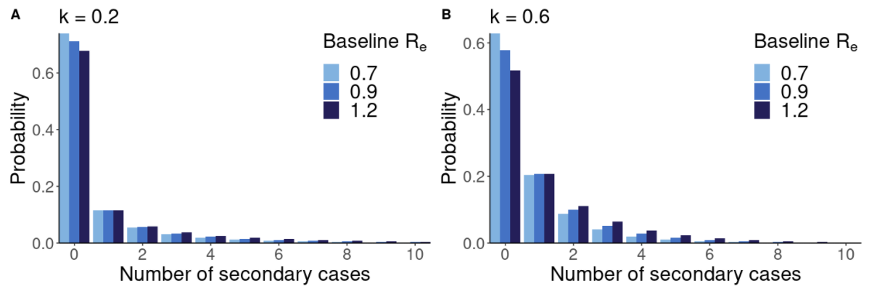
Supplementary Figure 1. Offspring distribution considering varying baseline effective reproduction numbers ($R_{b}$) and overdispersion parameter $k$.

