AIMS Environmental Science, 10(2):246–266.
DOI: 10.3934/environsci.2023015
Received: 29 November 2022
Revised：28 February 2023
Accepted: 09 March 2023
Published: 28 March 2023
http://www.aimspress.com/journal/environmental

Research article
Spanish business commitment to the 2030 Agenda in uncertain times
Francisco Manuel Somohano-Rodríguez^{1,}*, Fátima David² and Tania Cristina Azevedo³
¹ Santander Financial Institute, Universidad de Cantabria, Spain
² Instituto Politécnico de Guarda, Portugal
³ Universidade Estadual de Feira de Santana, Brasil
* Correspondence: Email: fm.somohano@unican.es.

Table S1. Business contributions to 2030 Agenda.

SDG | Business initiatives
Social action and volunteer programmes in general through alliances with NGOs in favour of groups at risk of social exclusion.
Agreements with public administrations to avoid cuts in supply and the promotion of alternative energy sources.
Developing products and services with advantageous conditions for certain groups.
Helping the most disadvantaged groups through solidarity festivals.
Broadcasting television programmes to promote equality.
Granting microcredits to groups at risk of poverty.
Supporting people affected by conflict and natural hazards, including access to basic services.
Hiring local suppliers to benefit economically and socially the environments in which they operate economically and socially.
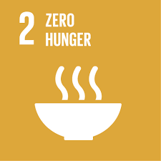 | Annual aid to soup kitchens.  Donating to aid organisations and food banks.  Classifying donated food and annual contributions by employees.  Contributing to prevent and curb food diseases.  Reformulating products so that they meet high-quality standards.  Supplying products under food certificates that guarantee their quality and health benefits.  Promoting healthy lifestyles.  Sustainable crops on a social and environmental level to achieve “sustainable agriculture”.  Contributing to reduce food waste, redirecting it to donations.  Volunteering, collaborations and various programmes to promote local development.
Policies and actions that ensure safe working conditions.
Corporate volunteer programmes in different hospitals to support the sick, with special emphasis on underage patients.
Supporting associations by carrying out various activities with disabled people.
Training courses for employees in cardiopulmonary resuscitation and management of defibrillators.
Road safety talks for employees to raise awareness about optimal vehicle maintenance.
Assisting blood donation campaigns.
Donations and grants for research on various diseases.
Requesting to install defibrillators in public places by collecting signatures.
Television programmes that address social exclusion.
Promoting healthy eating and lifestyles.
Insurance that covers basic needs and protects the family economy.
Funds for child vaccination campaigns.
Substituting highly polluting aircraft for others more efficient and environmentally friendly.
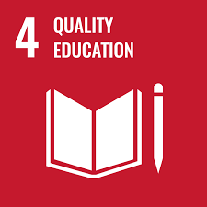 | Training campaigns in local communities where the activity takes place.  Donations to facilitate social mobility and guarantee equitable, inclusive and quality education.  Programmes to teach the Internet to the elderly, groups with low resources, disabled people, etc.  Television programmes focused on teaching and its importance.  Scholarship programmes for university entrepreneurs.  Promoting knowledge and skills to ensure good financial training and education.  Campaigns to improve the employability of workers.  Professional and academic guidance programmes for young people suffering social exclusion.  Collaboration agreements with universities for professional practices to be carried out by students.
Establishing an Equality framework and office within companies to guarantee gender equality.
Equal opportunities in selection and promotion processes.
Promoting diversity and work-life balance.
Radio programmes focused on topics such as sexist violence, the wage gap and other topics related to gender violence.
Fifty percent or more of the workforce of various entities being made up of women.
Programmes to promote female talent and generate an inclusive culture.
Equal opportunities included in the company’s Code of Ethics.
Protocols for the prevention of labour and sexual harassment integrated into company statutes.
Opening a complaints channel in companies to report any act that discriminates against or violates the rights of workers, especially women.
Supporting a great variety of cultures, beliefs, and languages ​​in the workforce, for the cultural enrichment of the company and the promotion of equality.
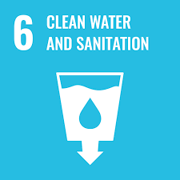 | Offering services and products that ensure the availability of water efficiently.  Developing drinking water, desalination and purification infrastructures to guarantee good-quality water.  Radio programmes on the environment and the use of water.  Protecting water for use by future generations.  Reducing the water used in the production process of various companies.  Supporting entities that manufacture chemical substances such as chlorine to ensure access to drinking water for the population.  Treating water in areas at risk of drought, benefiting local populations.  Business campaigns to reduce the number of unwanted substances dumped into the water.  Corporate reports that have a Water Control Action Plan to guarantee responsible practices and efficient use.  Contributing to paying the debts of various users, who, while intending to pay, have difficulties doing so.
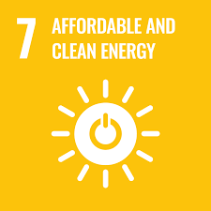 | Developing renewable energy generation facilities such as wind farms, towards a low carbon economy.  Developing photovoltaic and thermoelectric power plants with storage capacity.  Television programmes where analyses are carried out on the management of the energy business and the resolution of energy problems.  Plans to combat climate change which aim to neutralize C02 emissions by 2050.  Issuing green bonds and sustainable investment funds.  Using renewable energies in production processes.  Investments to improve the energy efficiency of various facilities.  Initiatives to use hydrogen to promote the use of clean energy.  Committing to satisfying access to energy to local populations with low resources where the company is present.  Renovating more efficient equipment that does not consume fossil fuel.  Developing ecological batteries applicable in electric vehicles.
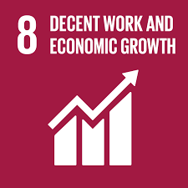 | Fostering social inclusion by promoting employment in the local communities out of the businesses.  Committing to remaining in the area where the company operates to promote local economic and social development.  Supporting unions and workers’ associations.  Business motivation to improve employees’ skills and efficiency of employees.  Entities with more than 90% permanent employees.  Promoting decent conditions in the value chain and for employees.  Campaigns to promote R + D in various territories.  Free help and diagnosis tools aimed at SMEs and the self-employed so that they can develop innovation and responsible management.  Programmes for labour insertion of people with intellectual disabilities supervised by expert entities in the field.  Campaigns to reduce the gender gap by increasing the presence of women in senior management positions and dealing with all cases of human rights violations.  Hiring local suppliers to contribute to local economic growth.  Job creation through financial offers from various banking entities.  Integrating a compensation policy and map to guarantee salary competitiveness and equitable payment among employees.  Programmes focused on generational change to guarantee the occupation of vacant positions within the workforce.  Adopting a global approach to align company policies in the different places where companies operate.  Scholarship programmes for recent graduates without professional experience.  Positive contribution to the gross domestic product (GDP) of the communities where companies operate.
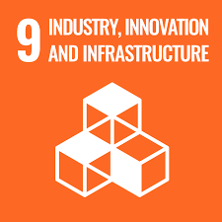 | Building infrastructures that respect the environment and the societies where the activity is carried out.  Programmes and investments to improve competitiveness, obtain greater efficiency in processes and minimise costs.  Automation and digitalization of processes depending on need.  Investments in technology, development and information security.  Action protocols to guarantee sustainable growth and avoid damaging the environment and local societies.  Providing digital equipment to employees.  Technological conditioning of business facilities according to need.  Implementing technological systems for better water and energy management.  Obtaining certificates of quality, safety, traceability, sustainability and efficiency.  Developing private technology centers to carry out R + D + i projects.  Optimising industrial plants for more efficient uses.  Offers and promotions accessible to the most disadvantaged groups to promote digital inclusion.
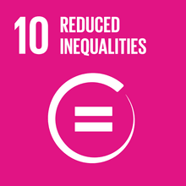 | Contributing to an adequate education to train professionals who promote equal opportunities.  Developing web portals accessible to the entire population.  Procedures to guarantee quality services.  Improving communication processes to avoid information asymmetry for the benefit of investors.  Collaborative agreements with foundations for the labour insertion of people with intellectual disabilities.  Developing products adapted for the most vulnerable groups in addition to training processes to manage their finances more efficiently.  Granting credits.  Supporting and financing programmes for small entrepreneurs.  Granting aid to rural areas to prevent depopulation, granting financial advice and improving agricultural and livestock facilities.  Negotiating with unions about wages, pensions, working conditions and equality.
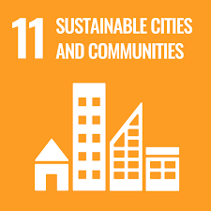 | Providing services to create more sustainable and efficient cities, such as constructing public transport, traffic management, sustainable buildings, etc.  Promoting sustainable coexistence in local societies where the activity is carried out.  Mitigating noise pollution and the emission of harmful gases by various means of transport.  Social support and aid projects in places that have suffered natural catastrophes.  Television programmes in which topics such as housing rental prices, government tax measures, etc. are discussed.  Financing for SMEs and the self-employed to contribute to local economic development and generate employment.  Digital programs to facilitate the activity of various companies, especially those focused on exporting products.  Offering sustainable credits by certain banking entities, in addition to providing financial solutions to clients.  Projects for more efficient management of public lighting.  The “Smart Cities” project, in which a large number of companies have been involved, which consists of a technological revolution allowing cities to be connected thanks to technology and become more efficient. It is also proposed as a solution to the environmental repercussions that urban planning causes throughout the world.  Programmes to improve urban and interurban mobility.  Developing civil drones that contribute to an improvement in services.  Investments aimed at reducing harmful gas emissions.  Various companies working in air transport are withdrawing the most polluting aircraft and are replacing them with others that are more environmentally friendly.  Obtaining environmental certifications that guarantee the company works in a way that respects the environment.  Programmes for more effective resource management.  Promoting circular economy activities, which propose reducing raw material waste and its reuse.
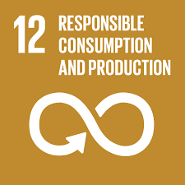 | Developing mechanisms to better control and manage the supply chain. In this way, adequate traceability can be guaranteed, and products can be controlled.  Intensive product labeling and certification processes in various companies to guarantee their quality and authenticity.  Recycling and reusing processes for waste to reduce consumption and costs.  Promotion of and contribution to education for sustainable and responsible consumption.  Reducing the consumption of resources such as paper and electricity by various companies in addition to promoting the use of renewable energy.  Carrying out social and environmental risk analysis in the projects to be carried out.  Support for circular economy projects for better waste management and reuse.  Programmes to recycle office supplies.  Donation campaigns of different computer equipment, furniture and other tools to educational centres and non-profit associations.  Financing projects that promote recycling and efficiency in the use of natural resources.  Developing indicators to calculate the environmental impact of the activities to be carried out.  Incorporating sustainability criteria into the Ethical Codes and policies of various companies.  Promoting the responsible use of resources to suppliers, subcontractors and employees.
Initiatives to reduce the emission of greenhouse gases through calculation, reduction and compensation processes.
Research and projects to promote the use of clean and renewable energy.
Analysing risks associated with climate change.
Creating technological solutions that help improve operational efficiency (eco-efficiency).
Awareness campaigns on the amount of carbon that various companies emit into the atmosphere.
Television programmes where information is broadcast on how to prevent forest fires in times of greatest risk.
Radio programmes aimed at achieving environmental awareness.
Financing renewable energy by banks; projects are also financed to achieve energy efficiency.
Support for, and financing of, vehicles that produce low emissions, such as electric and hybrid cars.
Developing sustainable products and services for companies and individuals.
Motivating and supporting customers and employees to implement eco-efficiency in their homes.
Policy updates to ban the use of thermal coal; some entities have even proposed the closure of their coal plants.
Products with environmental coverage, such as insurance for sustainable farmland or forest areas.
Environmental certifications, such as ISO 14001 (environmental certificate), also ISO 50001 (energy management certificate) and ISO 14064 (carbon footprint verification).
Collaboration with different NGOs for the conservation of biological diversity.
Performing energy audits to optimise the use of resources.
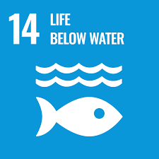 | Television programmes where experts discuss the problems caused by dumping plastics in the oceans.  Awareness campaigns on good daily actions to avoid polluting seas and oceans.  Manufacturing recyclable and reusable products to avoid creating more waste.  Container collection campaigns to keep coastal areas clean and protect marine biodiversity.  Studies on the quality of purified water from power plants to verify the environmental impact of its discharge into seas and rivers.  Ceasing activity in areas with greater water stress.  Preservation and protection criteria to minimise the impact of some companies’ actions.  Projects to recover marine species that have been affected by the performance of various actions.  Optimising water resources to reuse water or for it to be returned to the environment in optimal conditions.
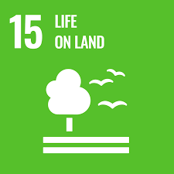 | Contributing to the organic regeneration of the soil through various projects.  Campaigns to protect native flora and fauna in the areas where the companies operate.  Campaigns to restore and repair the possible damage that may have been caused by certain activities, such as reforestation.  Television programmes on the impact of the disappearance of some animal species or the arrival of invasive species.  Collaborating with associations to prevent fires.  Manufacturing recyclable packaging.  Waste collection campaigns.  Promoting silvopastoral systems, which consist of combining trees, fodder shrubs and pastures with livestock production since it can contribute to greater soil fertilisation.  Degraded soil rehabilitation projects.  Sustainable financing for soil conservation and use.
Developing and incorporating good behaviour policies.
Initiatives to promote societies based on transparency and good governance where human rights are respected.
Creating a Code of Ethics and Conduct that must be accepted and complied with by all members of the entities.
Creating a conventional complaint channel to report on activities contrary to the ethical and regulatory framework.
Establishing anti-corruption and anti-fraud policies.
Campaigns to end all forms of violence and crime and promote the fulfilment of human rights.
Promoting equal opportunities and decent wages for workers.
Good-practice programmes and initiatives with shareholders, facilitating access to all information to favour decision-making, in addition to facilitating their participation in General Shareholders’ Meetings.
Creating a body within the company responsible for monitoring compliance with regulations and reporting those cases in which it is not carried out.
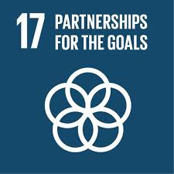 | Promoting transparency, dialogue and improvement of processes with the companies with which it collaborates.  Campaigns that seek business awareness about the problems and impact of company actions, as well as promoting joint collaboration with other organisations to mitigate this impact.  Multilateral agreements by various banking entities to finance energy efficiency projects.  Adherence to the principles of Responsible Banking.  Creating work groups to study adequate risk management.  Event promotion campaigns carried out jointly by various companies and administrations to support environmental and social entrepreneurship.  Creating alliances with companies from different sectors to take advantage of synergies that have a positive impact on society.  Campaigns for the joint promotion of the Sustainable Development Goals (SDGs) to promote their extension and subsequent adoption by as many companies as possible.  Extending compliance with the Code of Ethics to the supply chain.  Joint studies and research to develop more sustainable products.  Collective agreements to support education, health and well-being, promote culture and access to energy and help the most disadvantaged groups.  Alliances between companies and governments of different countries to contribute to a positive impact in the areas where the company operates.  Participation in dialogue forums to promote innovation and develop joint initiatives that allow the exchange of experiences and good practices.

© 2023 the Author(s), licensee AIMS Press. This is an open access article distributed under the terms of the Creative Commons Attribution License (http://creativecommons.org/licenses/by/4.0)

